UNITED STATES
SECURITIES AND EXCHANGE COMMISSION
WASHINGTON, D.C. 20549

FORM 8-K

CURRENT REPORT
Pursuant to Section 13 or 15(d) of the Securities Exchange Act of 1934
Date of Report (Date of earliest event reported): August 11, 2026

Aura Biosciences, Inc.
(Exact name of Registrant as Specified in Its Charter)

Delaware |  |  | 001-40971 | 32-0271970
(State or Other Jurisdiction  of Incorporation) |  |  | (Commission File Number) | (IRS Employer  Identification No.)
80 Guest Street
Boston, Massachusetts |  |  |  | 02135
(Address of Principal Executive Offices) |  |  |  | (Zip Code)

Registrant’s Telephone Number, Including Area Code: 617 500-8864

Not Applicable
(Former Name or Former Address, if Changed Since Last Report)

Check the appropriate box below if the Form 8-K filing is intended to simultaneously satisfy the filing obligation of the registrant under any of the following provisions:
☐Written communications pursuant to Rule 425 under the Securities Act (17 CFR 230.425)
☐Soliciting material pursuant to Rule 14a-12 under the Exchange Act (17 CFR 240.14a-12)
☐Pre-commencement communications pursuant to Rule 14d-2(b) under the Exchange Act (17 CFR 240.14d-2(b))
☐Pre-commencement communications pursuant to Rule 13e-4(c) under the Exchange Act (17 CFR 240.13e-4(c))
Securities registered pursuant to Section 12(b) of the Act:
Title of each class |  | Trading  Symbol(s) |  | Name of each exchange on which registered
Common Stock, $0.00001 par value per share |  | AURA |  | The Nasdaq Global Market
Indicate by check mark whether the registrant is an emerging growth company as defined in Rule 405 of the Securities Act of 1933 (§ 230.405 of this chapter) or Rule 12b-2 of the Securities Exchange Act of 1934 (§ 240.12b-2 of this chapter).
Emerging growth company ☒
If an emerging growth company, indicate by check mark if the registrant has elected not to use the extended transition period for complying with any new or revised financial accounting standards provided pursuant to Section 13(a) of the Exchange Act. ☐

Item 2.02 Results of Operations and Financial Condition.
On August 11, 2026, (the “Effective Date”), Aura Biosciences, Inc. (the “Company”) issued a press release announcing its financial results for the quarter ended June 30, 2026. A copy of the press release is furnished as Exhibit 99.1 to this Current Report on Form 8-K.
The information in this Item 2.02, including Exhibit 99.1 hereto, shall not be deemed “filed” for purposes of Section 18 of the Securities Exchange Act of 1934, as amended (the “Exchange Act”), or otherwise subject to the liabilities of that section, nor shall it be deemed incorporated by reference in any filing under the Securities Act of 1933, as amended, or the Exchange Act, except as expressly set forth by specific reference in such a filing.

Item 2.05 Costs Associated with Exit or Disposal Activities

On the Effective Date the Company announced its organizational realignment (the “Realignment”) to streamline its operating plan and organizational structure to focus resources in ocular oncology, including its plan to minimize resource allocation towards its non-muscle invasive bladder cancer (“NMIBC”) program on a going forward basis. As part of the Realignment, the Company plans to reduce its workforce by approximately 20%. Impacted employees are eligible to receive severance benefits. These severance benefits are contingent upon an impacted employee’s execution (and non-revocation) of a severance agreement, which includes a general release of claims against the Company.

The total cash payments and costs related to the Realignment and reducing the workforce are estimated to be approximately $2.9 million to $3.2 million, with a significant majority of these amounts expected to be paid in the third quarter of 2026. These estimates are subject to a number of assumptions and actual results may differ. The Company may also incur additional costs not currently contemplated due to events that may occur as a result of, or that are associated with, the corporate restructuring.

Item 5.02 Departure of Directors or Certain Officers; Election of Directors; Appointment of Certain Officers; Compensatory Arrangements of Certain Officers
Appointment of Chief Operating Officer
On August 6, 2026, the Board appointed Susan Abu-Absi, Ph.D., age 52, as the Company’s Chief Operating Officer, effective as of August 10, 2026 (the “Start Date”). Prior to joining the Company, Dr. Abu-Absi served as Chief Operating Officer at Be Biopharma, Inc. from February 2025 to June 2026, where she led the company's operational strategy and execution. Prior to Be Biopharma, Dr. Abu-Absi was Chief Technology Officer at 2seventy bio, Inc. from November 2021 to May 2024, leading technical development, supply and quality. Previously, Dr. Abu-Absi was Senior Vice President, Technical Development & Operations at bluebird bio, Inc. from January 2019 to November 2021, and earlier in her career held senior leadership roles at Bristol Myers Squibb and Bayer Healthcare. Dr. Abu-Absi holds a Ph.D. in Chemical Engineering from the University of Minnesota and a B.S. in Chemical Engineering from the University of Toledo.
In connection with her appointment as Chief Operating Officer, Dr. Abu-Absi entered into an offer letter (the “Abu-Absi Employment Offer Letter”), effective as of the Start Date, setting forth the terms of her employment with the Company. Pursuant to the Abu-Absi Employment Offer Letter, Dr. Abu-Absi will be paid an annual base salary of $520,000. Following the end of each calendar year, Dr. Abu-Absi will be eligible to receive a discretionary annual performance bonus with a target of 45% of her then annual base salary based upon the Board’s assessment of the Company’s achievement of its performance goals and Dr. Abu-Absi’s continued employment with the Company. Dr. Abu-Absi is also eligible to participate in the Severance Plan as a Tier Two Executive (as defined in the Severance Plan), which provides for severance payments and benefits to Dr. Abu-Absi in the event that the Company terminates her employment without Cause or if Dr. Abu-Absi resigns with Good Reason (each as defined in the Severance Plan). The foregoing description of the Severance Plan does not purport to be complete and is qualified in its entirety by the full text of the Severance Plan, a copy of which was filed with the SEC as Exhibit 10.3 to the Company’s Quarterly Report on Form 10-Q for the quarter ended September 30, 2024 (File No. 001-40971) as filed with the SEC on November 12, 2024.
In connection with her appointment as the Company’s Chief Operating Officer and as an inducement to entering into the Abu-Absi Employment Offer Letter, the Company intends to grant Dr. Abu-Absi an equity award of approximately 400,000 shares of the Company’s common stock, comprised of approximately 60 percent a stock option to purchase shares of the Company’s common stock (the “Abu-Absi Option Award”) and 40 percent restricted stock units for shares of the Company’s common stock (“Abu-Absi RSUs”), in each case, based on the grant-date fair value and as determined by the Board. Both the Abu-Absi Option Award and the Abu-Absi RSUs are expected to be approved by the Compensation Committee of the Board without stockholder approval pursuant the Inducement Award Exception, will be granted outside of the 2021 Plan and will be subject to terms substantially similar to the 2021 Plan and the forms of award agreements thereunder. The exercise price of the Abu-Absi Option Award will equal the fair market value of the Company’s common stock on The Nasdaq Global Market on the date of grant. The Abu-Absi Option Award will vest as follows: 25% shall vest and become exercisable on the first anniversary of the Effective Date, and 2.0834% shall vest and become exercisable on a monthly basis thereafter over the following 36 months, subject to Dr. Abu-Absi’s continued service as of each vesting date. The Abu-Absi RSUs will vest as follows: 25% shall vest on the first anniversary of the 15th of the month in which grant occurs (the “First Vesting Date”), and 25% shall vest on each of the first year anniversary, second year anniversary, and third year anniversary of the First Vesting Date, subject to Dr. Abu-Absi’s continued service as of each vesting date.

In addition, Dr. Abu-Absi has entered into an indemnification agreement with the Company, the form of which was filed with the SEC as Exhibit 10.7 to the Company’s Registration Statement on Form S-1 (File No. 333-260156) as initially filed with the SEC on October 8, 2021 and declared effective on October 28, 2021, pursuant to which the Company may be required, among other things, to indemnify Dr. Abu-Absi for certain expenses (including reasonable attorneys’ fees), judgments, fines, penalties, excise taxes and settlement amounts actually and reasonably incurred by her in any action or proceeding arising out of her service as an officer or director of the Company. Dr. Abu-Absi has also entered into an agreement with the Company that contains a non-solicitation provision that apply during and for one year following her employment with the Company, an invention assignment provision, and a non-disclosure provision that applies during and following her employment with the Company.
There are currently no arrangements or understandings between Dr. Abu-Absi and any other person pursuant to which Dr. Abu-Absi was appointed as Chief Operating Officer of the Company and there are no family relationships between Dr. Abu-Absi and any of the Company’s directors or executive officers. There are currently no transactions in which Dr. Abu-Absi has an interest requiring disclosure under Item 404(a) of Regulation S-K.
The foregoing description of the Abu-Absi Employment Offer Letter does not purport to be complete and is qualified in its entirety by the full text of the Abu-Absi Employment Offer Letter, a copy of which will be filed as an exhibit to the Company’s Quarterly Report on Form 10-Q for the quarter ending September 30, 2026.
Departure of Chief Financial and Business Officer
On August 10, 2026, the Company and Anthony Gibney, the Company’s Chief Financial and Business Officer, entered into a Separation Agreement (the “Gibney Separation Agreement”), effective as of September 1, 2026 (the “Gibney Separation Date”). The Gibney Separation Agreement provides that Mr. Gibney will receive continued salary through the Gibney Separation Date subject to Mr. Gibney’s performance of certain Transition Services (as defined in the Gibney Separation Agreement).
Subject to entering into a release of claims in favor of the Company, under the Gibney Separation Agreement, Mr. Gibney will be entitled to receive (i) severance pay equal to continuation of his annual base salary for nine (9) months immediately following the Effective Date (as defined in the Gibney Separation Agreement), (ii) subject to Mr. Gibney’s timely election to continue health coverage under the Consolidated Omnibus Budget Reconciliation Act (“COBRA”) and copayment of premium amounts at the applicable active employees’ rate, a monthly payment equal to the amount that the Company would have paid to provide health insurance to Mr. Gibney until the earlier of June 30, 2027, eligibility for medical care coverage through other employment or termination of eligibility under COBRA. The Gibney Separation Agreement also includes customary confidentiality and non-disparagement provisions.
Additionally, pursuant to a Consulting Agreement with the Company, effective as of the Gibney Separation Date (the “Gibney Consulting Agreement”), Mr. Gibney will provide consulting services to the Company beginning on the Gibney Separation Date through May 31, 2027 (such period, the “Consulting Period”). Pursuant to the Gibney Consulting Agreement, subject to Mr. Gibney entering into a release of claims in favor of the Company, Mr. Gibney’s previously granted equity awards outstanding as of the Termination Date shall continue to vest during the Consulting Period; provided that if the Company terminates the Gibney Consulting Agreement for Cause (as defined in the Gibney Consulting Agreement) or if Mr. Gibney terminates the Gibney Consulting Agreement for any reason, such equity awards shall immediately cease vesting.
The foregoing descriptions of the Gibney Consulting Agreement and the Gibney Separation Agreement do not purport to be complete and are qualified in their entirety by the full text of the Gibney Consulting Agreement and the Gibney Separation Agreement, respectively, copies of which will be filed as exhibits to the Company’s Quarterly Report on Form 10-Q for the quarter ending September 30, 2026.
Appointment of Interim Principal Financial Officer
In connection with Mr. Gibney’s departure, on August 6, 2026, the Board appointed Amy Elazzouzi as the Company’s Senior Vice President, Finance, Treasurer and Secretary, effective as of September 2, 2026 (the “Elazzouzi Effective Date”). In addition, the Board confirmed that, effective as of the Elazzouzi Effective Date, Ms. Elazzouzi will serve as the Company’s interim principal financial officer until such time as the Board appoints a Chief Financial Officer of the Company.
Ms. Elazzouzi, age 53, currently serves as the Company’s Senior Vice President of Finance, Treasurer and Secretary, and principal accounting officer, and has served in various roles with the Company since 2015. Prior to joining the Company, Ms. Elazzouzi served as Director of Finance and Operations at KEW Group, Inc. and Controller at AVEO Pharmaceuticals, Inc. Ms. Elazzouzi holds an MBA from Northeastern University and a BA from Regis College.
There are currently no arrangements or understandings between Ms. Elazzouzi and any other person pursuant to which Ms. Elazzouzi was appointed as the Company’s interim principal financial officer of the Company, and there are no family relationships between Ms. Elazzouzi and any of the Company’s directors or executive officers. There are currently no transactions in which Ms. Elazzouzi has an interest requiring disclosure under Item 404(a) of Regulation S-K.

Item 8.01 Other Events.
On August 11, 2026, the Company updated its corporate presentation for use in meetings with investors, analysts, and others. A copy of the corporate presentation is filed as Exhibit 99.2 for purposes of Section 18 of the Exchange Act.

Cautionary Note Regarding Forward Looking Statements
Statements contained under this Item 8.01 and in certain of the materials filed herewith regarding matters that are not historical facts are “forward-looking statements” within the meaning of the Private Securities Litigation Reform Act of 1995, as amended. Because such statements are subject to risks and uncertainties, actual results may differ materially from those expressed or implied by such forward-looking statements. Such statements include, but are not limited to, statements about the initiation, timing, progress, results, and cost of the Company’s research and development programs and the Company’s current and future preclinical studies and clinical trials, including statements regarding the timing of initiation and completion of studies or trials and related preparatory work, the period during which the results of the trials will become available, and the Company’s research and development programs; statements regarding the Company’s expectations for an improved quality of life of patients after treatment with bel-sar and changes to the treatment paradigm for patients; the Company’s ability to efficiently develop existing product candidates and discover new product candidates; the Company’s ability to successfully manufacture its drug substances and product candidates for preclinical use, for clinical trials and on a larger scale for commercial use, if approved; the ability and willingness of the Company’s third-party strategic collaborators to continue research and development activities relating to the Company’s development candidates and product candidates; the Company’s ability to commercialize its products, if approved; the Company’s ability to obtain additional funding for its operations necessary to complete further development and commercialization of its product candidates; the Company’s ability to obtain and maintain regulatory approval of its product candidates; statements regarding the Company’s beliefs and expectations for the high unmet medical need for an effective local treatment in ocular and urologic oncology to preserve organ function; the size and growth potential of the markets for the Company’s product candidates, and the Company’s ability to serve those markets; the Company’s financial performance; the Company’s expected cash runway into the first half of 2029; the Realignment; and the implementation of the Company’s business model, including strategic plans for its business and product candidates.
Any forward-looking statements are neither promises nor guarantees, and investors should not place undue reliance on these forward-looking statements because they involve known and unknown risks, uncertainties, and other factors, many of which are beyond the Company’s control and which could cause actual results to differ materially from those expressed or implied by these forward-looking statements, including, without limitation, uncertainties inherent in clinical trials and in the availability and timing of data from ongoing clinical trials; the expected timing for submissions for regulatory approval or review by governmental authorities; the risk that the results of the Company’s preclinical and clinical trials may not be predictive of future results in connection with future clinical trials; the risk that early or interim data from ongoing clinical trials may not be predictive of final data from completed clinical trials; the risk that governmental authorities may disagree with the Company’s clinical trial designs, even where the Company has obtained agreement with governmental authorities on the design of such trials, such as the Phase 3 Special Protocol agreement with the U.S. Food and Drug Administration; whether the Company will receive regulatory approvals to conduct trials or to market products; whether the Company’s cash resources will be sufficient to fund its foreseeable and unforeseeable operating expenses and capital expenditure requirements; the Company’s ongoing and planned preclinical activities; and the Company’s ability to initiate, enroll, conduct or complete ongoing and planned clinical trials. These risks, uncertainties, and other factors include those risks and uncertainties described under the heading “Risk Factors” in the Company’s most recent Annual Report on Form 10-K and Quarterly Report on Form 10-Q filed with the U.S. Securities and Exchange Commission (“SEC”) and in subsequent filings made by the Company with the SEC, which are available on the SEC’s website at www.sec.gov. Except as required by law, the Company disclaims any intention or responsibility for updating or revising any forward-looking statements contained under this Item 8.01 or in the materials filed herewith in the event of new information, future developments or otherwise. These forward-looking statements are based on the Company’s current expectations and speak only as of the date hereof and no representations or warranties (express or implied) are made about the accuracy of any such forward-looking statements.
Item 9.01 Financial Statements and Exhibits.
(d) Exhibits.
Exhibit No. | Description
99.1 | Press Release Dated August 11, 2026.
99.2 | Corporate Presentation of the Company.
104 | Cover Page Interactive Data File (embedded within the Inline XBRL document).

SIGNATURES
Pursuant to the requirements of the Securities Exchange Act of 1934, the registrant has duly caused this report to be signed on its behalf by the undersigned hereunto duly authorized.

 |  |  | Aura Biosciences, Inc.
Date: | August 11, 2026 | By: | /s/ Natalie Holles
Natalie Holles
Chief Executive Officer and President
(Principal Executive Officer)

Exhibit 99.1


Aura Biosciences Reports Second Quarter 2026 Financial Results and Recent Business Highlights

Phase 3 CoMpass trial fully enrolled with 108 patients, exceeding enrollment target; on track for topline data in 2H 2027

Strategic operating plan refined to focus on development of bel-sar in ocular oncology

Interim NMIBC data reinforce bel-sar’s potential for durable efficacy and favorable safety profile; NMIBC program being strategically deprioritized to focus company resources on ocular oncology

Organizational restructuring and disciplined capital allocation strategy to align with ocular oncology focus extend expected cash runway into 1H 2029

Strengthening leadership team with appointments of experienced industry executives as Chief Operating Officer, Chief Regulatory and Quality Officer, and Chief People Officer to position Aura for next stage of growth

BOSTON, MA – August 11, 2026 – Aura Biosciences, Inc. (NASDAQ: AURA), a clinical-stage biotechnology company developing a potentially transformative first-in-class therapy for patients with ocular cancers, today reported financial results for the second quarter ended June 30, 2026, and provided a business update.

"Completing enrollment in our Phase 3 CoMpass trial of bel-sar for early choroidal melanoma positions us well for the next phase of our company’s evolution to become a leading ocular oncology company," said Natalie Holles, Chief Executive Officer of Aura Biosciences. "Given the promising therapeutic profile of bel-sar and the significant unmet need for a new treatment in this field, we are prioritizing our efforts and resources on delivering meaningful development milestones, providing ocular oncologists with frontline, vision-preserving treatment options for patients, and creating long-term value for shareholders."

Recent Business Highlights
Early Choroidal Melanoma

The Phase 3 CoMpass trial, the first registration-enabling study in patients with early choroidal melanoma, is fully enrolled with 108 patients, which exceeded the enrollment target. Topline data from the 15-month primary endpoint remain on track for the second half of 2027, consistent with previously communicated guidance.

The trial is being conducted under a Special Protocol Assessment (SPA) agreement with the U.S. Food and Drug Administration (FDA), reflecting alignment with the FDA on the trial design and planned analyses to support a potential Biologics License Application (BLA). If successful, belzupacap sarotalocan (bel-sar) has the potential to become the first approved frontline vision-preserving therapy for patients with early choroidal melanoma, providing a meaningful new treatment option where no FDA-approved drug therapies currently exist.

Additional Ocular Oncology Programs
Aura continues to advance the clinical development of bel-sar in metastases to the choroid and cancers of the ocular surface. The Company is increasing resources directed toward both programs to support more robust clinical data generation in support of future development. Aura expects to provide an update on both programs, including guidance on study completion, in Q1 2027.

NMIBC Program Update
Interim data from the ongoing Phase 1b/2 dose-escalation study of bel-sar in non-muscle invasive bladder cancer (NMIBC) demonstrate an encouraging early clinical profile. Among intermediate-risk patients treated with bel-sar alone (n=8) or with TURBT (n=8), 81% of patients achieved an objective response at 3 months, including 69% with a complete response at that timepoint. Responses have shown strong early durability: among evaluable patients who have reached the 9- (n=4) or 12-months (n=3) timepoints, 100% of evaluable patients remain disease-free at time of assessment. Three-month data collection is ongoing in the high-risk cohorts.

Bel-sar continues to demonstrate a favorable safety profile, with all treatment-related adverse events limited to Grade 1 events, no dose-limiting toxicities, and no treatment-related serious adverse events. These data provide encouraging early clinical proof-of-concept for intratumoral delivery of bel-sar and support the potential utility of this route of administration for ocular cancers.

While these early data are encouraging, as part of its strategic refocus on ocular oncology, the Company is minimizing resource allocation toward the NMIBC program on a going forward basis. The Company remains committed to the care of patients and intends to complete data collection through the protocol-defined 12-month follow-up period to preserve optionality for value creation in the context of future potential strategic discussions.

Organizational and Leadership Updates

Aura has streamlined its operating plan and organizational structure to focus resources in ocular oncology, including a reduction in force of approximately 20% of the workforce. Together with disciplined capital allocation, these actions are expected to extend the Company's projected cash runway into the first half of 2029 to support execution of the Phase 3 CoMpass trial, advancement of its additional ocular oncology programs and preparation for potential commercialization.

Aura today announced the appointments of Susan Abu-Absi as Chief Operating Officer, Erica Kratz as Chief Regulatory and Quality Officer, and Julie Person as Chief People Officer. As previously announced on July 8, 2026, Jeremy Bender also joined the Company's Board of Directors.

"I am thrilled to welcome Susan, Erica and Julie to Aura," said Natalie Holles. "As we sharpen our focus on ocular oncology and advance bel-sar toward potential BLA filing, we are building a fit-for-purpose organization with the capabilities needed for our next stage of growth. Their collective experience will be invaluable as we execute on our strategy and prepare for potential registration and commercialization."

Aura also announced that Tony Gibney, Chief Financial and Business Officer and Conor Kilroy, Chief Legal Officer are stepping down, and Mark Plavsic has stepped down as Chief Technology Officer.

"On behalf of the Board and the entire Aura team, I want to thank Tony, Conor and Mark for their leadership and contributions to Aura," said Natalie Holles. "Each has played an important role in advancing the Company and positioning Aura for this next chapter, and we wish them all the very best in their future endeavors."

Susan Abu-Absi, Ph.D., Chief Operating Officer
Susan Abu-Absi, Ph.D., is a seasoned biopharmaceutical executive with more than 20 years of leadership experience spanning technical development, manufacturing, quality and global operations. Most recently, she served as Chief Operating Officer at Be Biopharma, where she led the company's operational strategy and execution. Prior to Be Biopharma, she was Chief Technology Officer at 2seventy bio, leading technical development, supply and quality and supporting the commercialization of Abecma® as well as the advancement of multiple cell therapy programs. Previously, Susan held senior leadership roles at bluebird bio, where she played an integral role in the approvals of Zynteglo® and Skysona®, and at Bristol Myers Squibb and Bayer Healthcare. She holds a Ph.D. in Chemical Engineering from the University of Minnesota and a B.S. in Chemical Engineering from the University of Toledo.

Erica Kratz, Ph.D., Chief Regulatory and Quality Officer
Erica Kratz, Ph.D., is a regulatory affairs and quality executive with more than 20 years of experience leading global regulatory strategy and development quality across the biotechnology industry. Most recently, she served as Senior Vice President, Regulatory Affairs and Head of Development Quality Assurance at Denali Therapeutics, where she built and led the team from the company's first clinical trial through the advancement of multiple programs into the clinic, including the BLA submission and FDA approval of Avlayah® in Hunter Syndrome. Prior to Denali, Erica spent a decade at Genentech, where she led global regulatory strategy for multiple oncology programs spanning early development through commercialization, including U.S. and Canadian marketing applications for Herceptin® in gastric cancer. She holds a Ph.D. in Molecular and Cell Biology from the University of California, Berkeley and a B.S. in Cell and Molecular Biology from the University of Arizona.

Julie Person, Chief People Officer
Julie Person is a human resources executive with more than 20 years of experience leading people strategy and organizational development across the biopharmaceutical industry. Most recently, she served as Chief People Officer at Vera Therapeutics. Prior to Vera, Julie served as Chief People Officer at Third Harmonic Bio and held senior human resources leadership roles at Neumora Therapeutics, Audentes Therapeutics, Sangamo Therapeutics, Shire, Blue Shield of California and McKesson. Her experience spans organizational design, talent acquisition, leadership development, culture and change management, supporting organizations through all stages of growth from early development to commercialization. She holds a B.A. in Communications from Saint Mary’s College of California.

Second Quarter 2026 Financial Results

•
As of June 30, 2026, Aura had cash and cash equivalents and marketable securities totaling $323.8 million. The Company believes its current cash and cash equivalents and marketable securities are sufficient to fund its operations into 1H 2029.

•
Research and development expenses increased to $30.7 million for the three months ended June 30, 2026 from $22.9 million for the three months ended June 30, 2025, primarily due to ongoing clinical and CRO costs associated with the progression of the CoMpass global Phase 3 trial of bel-sar in early choroidal melanoma and manufacturing and development costs for bel-sar.

•
General and administrative expenses increased to $17.3 million for the three months ended June 30, 2026 from $5.7 million for the three months ended June 30, 2025. General and administrative expenses include $10.3 million and $1.8 million of stock-based compensation for the three months ended June 30, 2026 and 2025, respectively. The increase was primarily driven by increased stock-based compensation expense resulting from equity award modifications in connection with executive leadership transitions, as well as higher professional fees.

•
Net loss for the three months ended June 30, 2026 was $45.6 million compared to $27.0 million for the three months ended June 30, 2025.

•
In connection with the Company's organizational restructuring to align resources behind its ocular oncology portfolio, the Company estimates to incur restructuring charges of approximately $2.9 million to $3.2 million, comprised of employee termination benefits which include severance, continuation of health care benefits, and outplacement services as well as incremental stock-based compensation expense resulting from the acceleration of vesting of certain stock-based awards. The restructuring plan is expected to be substantially complete by the end of the third quarter of 2026.

About Aura Biosciences
Aura Biosciences is a clinical-stage biotechnology company developing bel-sar, a potentially transformative, first-in-class therapy for patients living with ocular cancers. Bel-sar represents an entirely novel approach to treating ocular cancers via its dual mechanisms of action of acute tumor necrosis and secondary anti-tumor immune activation. The Phase 3 registration study of Bel-sar in early choroidal melanoma, the largest patient segment of uveal melanoma, is fully enrolled, and earlier stage studies in metastases to the choroid and cancers of the ocular surface are ongoing. Aura's mission is to improve outcomes for patients living with ocular cancers by delivering a therapy that not only arrests tumor growth but also preserves vision and quality of life.
For more information, visit aurabiosciences.com. Follow us on X, @AuraBiosciences, and visit us on LinkedIn.
Forward-Looking Statements
This press release contains forward-looking statements within the meaning of the Private Securities Litigation Reform Act of 1995, as amended, and other federal securities laws. Any statements that are not statements of historical fact may be deemed to be forward-looking statements. Words such as “may,” “will,” “could,” “should,” “expects,” “intends,” “plans,” “anticipates,” “believes,” “estimates,” “predicts,” “projects,” “seeks,” “endeavor,” “potential,” “continue” or the negative of such words or other similar expressions can be used to identify forward-looking statements. These forward-looking statements include express or implied statements regarding Aura’s future expectations, plans and prospects, including, without limitation, statements regarding the therapeutic potential of bel-sar; statements regarding Aura’s plans and expectations for its ongoing and future clinical trials of bel-sar in multiple oncology indications, including with respect to clinical trial initiations; statements regarding the timing and plans for the Company’s Phase 3 CoMpass trial in early choroidal melanoma, including the timing of topline data; statements regarding the timing and plans for data with respect to its Phase 2 clinical trial of bel-sar for the treatment of metastases to the choroid and Phase 1 proof-of-concept study of bel-sar for the treatment of cancers of the ocular surface; statements regarding Aura’s expectations for an improved quality of life of patients after treatment with bel-sar and changes to the treatment paradigm for patients; statements regarding Aura’s expectations for the estimated patient populations and related market opportunities for bel-sar; statements regarding the Company’s expected cash runway; statements regarding the expected costs and cost reductions associated with the restructuring; and statements regarding potential strategic discussions.

The forward-looking statements in this press release are neither promises nor guarantees, and investors should not place undue reliance on these forward-looking statements because they involve known and unknown risks, uncertainties and other factors, many of which are beyond Aura’s control and which could cause actual results to differ materially from those expressed or implied by these forward-looking statements, including, without limitation, uncertainties inherent in clinical trials and in the availability and timing of data from ongoing clinical trials; the expected timing for submissions for regulatory approval or review by governmental authorities; the risk that the results of Aura’s preclinical and clinical trials may not be predictive of future results in connection with future clinical trials; the risk that early or interim data from ongoing clinical trials may not be predictive of final data from completed clinical trials; the risk that governmental authorities may disagree with Aura’s clinical trial designs, even where Aura has obtained agreement with governmental authorities on the design of such trials, such as the Phase 3 special protocol assessment agreement with the U.S. Food and Drug Administration; whether Aura will receive regulatory approvals to conduct trials or to market products; whether Aura’s cash resources will be sufficient to fund its foreseeable and unforeseeable operating expenses and capital expenditure requirements; Aura’s ongoing and planned preclinical activities; and Aura’s ability to initiate, enroll, conduct or complete ongoing and planned clinical trials. These risks, uncertainties and other factors include those risks and uncertainties described under the heading “Risk Factors” in Aura’s most recent Annual Report on Form 10-K and Quarterly Report on Form 10-Q filed with the United States Securities and Exchange Commission (SEC) and in subsequent filings made by Aura with the SEC, which are available on the SEC’s website at www.sec.gov/. Except as required by law, Aura disclaims any intention or responsibility for updating or revising any forward-looking statements contained in this press release in the event of new information, future developments or otherwise. These forward-looking statements are based on Aura’s current expectations and speak only as of the date hereof and no representations or warranties (express or implied) are made about the accuracy of any such forward-looking statements.
Investor and Media Relations Contact:
Alex Dasalla
Head of Investor Relations and Corporate Communications
IR@aurabiosciences.com

Aura Biosciences, Inc.
Condensed Consolidated Statements of Operations and Comprehensive Loss
(Unaudited)
(in thousands, except share and per share amounts)

 |  | Three Months Ended  June 30, |  |  |  |  |  |  | Six Months Ended  June 30,
 |  | 2026 |  |  |  | 2025 |  |  | 2026 |  |  |  | 2025
Operating Expenses:
Research and development |  | $ | 30,749 |  |  | $ | 22,882 |  | $ | 58,709 |  |  | $ | 46,225
General and administrative |  |  | 17,320 |  |  |  | 5,731 |  |  | 24,226 |  |  |  | 11,423
Total operating expenses |  |  | 48,069 |  |  |  | 28,613 |  |  | 82,935 |  |  |  | 57,648
Total operating loss |  |  | (48,069 | ) |  |  | (28,613 | ) |  | (82,935 | ) |  |  | (57,648 | )
Other income (expense):
Interest income, including amortization and accretion income |  |  | 2,307 |  |  |  | 1,678 |  |  | 3,497 |  |  |  | 3,271
Other income (expense) |  |  | 154 |  |  |  | (36 | ) |  | 155 |  |  |  | (59 | )
Total other income |  |  | 2,461 |  |  |  | 1,642 |  |  | 3,652 |  |  |  | 3,212
Loss before income taxes |  |  | (45,608 | ) |  |  | (26,971 | ) |  | (79,283 | ) |  |  | (54,436 | )
Income tax provision, net |  |  | (29 | ) |  |  | (48 | ) |  | (39 | ) |  |  | (66 | )
Net loss |  | $ | (45,637 | ) |  | $ | (27,019 | ) | $ | (79,322 | ) |  | $ | (54,502 | )
Net loss per common share—basic and diluted |  | $ | (0.48 | ) |  | $ | (0.47 | ) | $ | (0.98 | ) |  | $ | (1.01 | )
Weighted average common stock outstanding—basic and diluted |  |  | 94,863,400 |  |  |  | 58,015,718 |  |  | 81,231,222 |  |  |  | 54,092,728
Comprehensive loss:
Net loss |  | $ | (45,637 | ) |  | $ | (27,019 | ) | $ | (79,322 | ) |  | $ | (54,502 | )
Other comprehensive income (loss):
Unrealized loss on marketable securities |  |  | (290 | ) |  |  | (88 | ) |  | (368 | ) |  |  | (226 | )
Currency translation adjustment |  |  | (173 | ) |  |  | 8 |  |  | (200 | ) |  |  | (12 | )
Total other comprehensive loss |  |  | (463 | ) |  |  | (80 | ) |  | (568 | ) |  |  | (238 | )
Total comprehensive loss |  | $ | (46,100 | ) |  | $ | (27,099 | ) | $ | (79,890 | ) |  | $ | (54,740 | )

Aura Biosciences, Inc.
Condensed Consolidated Balance Sheets
(Unaudited)
(in thousands, except share and per share amounts)

 |  | June 30, 2026 |  |  |  | December 31, 2025
Assets
Current assets:
Cash and cash equivalents |  | $ | 67,836 |  |  | $ | 59,515
Marketable securities |  |  | 256,004 |  |  |  | 84,726
Prepaid expenses and other current assets |  |  | 5,188 |  |  |  | 5,498
Total current assets |  |  | 329,028 |  |  |  | 149,739
Restricted cash and deposits |  |  | 768 |  |  |  | 768
Right-of-use assets - operating lease |  |  | 14,993 |  |  |  | 15,828
Other long-term assets |  |  | 1,139 |  |  |  | 471
Property and equipment, net |  |  | 2,201 |  |  |  | 2,624
Total Assets |  | $ | 348,129 |  |  | $ | 169,430
Liabilities and Stockholders’ Equity
Current liabilities:
Accounts payable |  |  | 2,254 |  |  |  | 1,549
Short-term operating lease liability |  |  | 3,292 |  |  |  | 3,243
Accrued expenses and other current liabilities |  |  | 14,014 |  |  |  | 13,591
Total current liabilities |  |  | 19,560 |  |  |  | 18,383
Long-term operating lease liability |  |  | 13,302 |  |  |  | 14,134
Total Liabilities |  |  | 32,862 |  |  |  | 32,517
Commitments and Contingencies
Stockholders’ Equity:
Common stock, $0.00001 par value, 150,000,000 authorized at June 30, 2026 and December 31, 2025, and 103,480,053 and 63,587,777 shares issued and outstanding at June 30, 2026 and December 31, 2025, respectively |  |  | 1 |  |  |  | —
Additional paid-in capital |  |  | 914,769 |  |  |  | 617,433
Treasury stock, at cost, 6,922,870 shares held at June 30, 2026 and no shares held at December 31, 2025 |  |  | (39,093 | ) |  |  | —
Accumulated deficit |  |  | (559,740 | ) |  |  | (480,418 | )
Accumulated other comprehensive loss |  |  | (670 | ) |  |  | (102 | )
Total Stockholders’ Equity |  |  | 315,267 |  |  |  | 136,913
Total Liabilities and Stockholders’ Equity |  | $ | 348,129 |  |  | $ | 169,430


August 2026 Exhibit 99.2

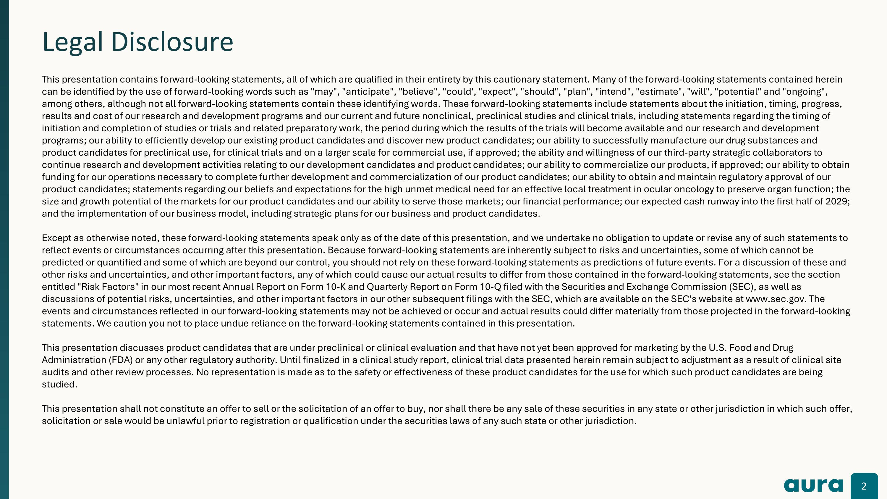
Legal Disclosure This presentation contains forward-looking statements, all of which are qualified in their entirety by this cautionary statement. Many of the forward-looking statements contained herein can be identified by the use of forward-looking words such as "may", "anticipate", "believe", "could', "expect", "should", "plan", "intend", "estimate", "will", "potential" and "ongoing", among others, although not all forward-looking statements contain these identifying words. These forward-looking statements include statements about the initiation, timing, progress, results and cost of our research and development programs and our current and future nonclinical, preclinical studies and clinical trials, including statements regarding the timing of initiation and completion of studies or trials and related preparatory work, the period during which the results of the trials will become available and our research and development programs; our ability to efficiently develop our existing product candidates and discover new product candidates; our ability to successfully manufacture our drug substances and product candidates for preclinical use, for clinical trials and on a larger scale for commercial use, if approved; the ability and willingness of our third-party strategic collaborators to continue research and development activities relating to our development candidates and product candidates; our ability to commercialize our products, if approved; our ability to obtain funding for our operations necessary to complete further development and commercialization of our product candidates; our ability to obtain and maintain regulatory approval of our product candidates; statements regarding our beliefs and expectations for the high unmet medical need for an effective local treatment in ocular oncology to preserve organ function; the size and growth potential of the markets for our product candidates and our ability to serve those markets; our financial performance; our expected cash runway into the first half of 2029; and the implementation of our business model, including strategic plans for our business and product candidates. Except as otherwise noted, these forward-looking statements speak only as of the date of this presentation, and we undertake no obligation to update or revise any of such statements to reflect events or circumstances occurring after this presentation. Because forward-looking statements are inherently subject to risks and uncertainties, some of which cannot be predicted or quantified and some of which are beyond our control, you should not rely on these forward-looking statements as predictions of future events. For a discussion of these and other risks and uncertainties, and other important factors, any of which could cause our actual results to differ from those contained in the forward-looking statements, see the section entitled "Risk Factors" in our most recent Annual Report on Form 10-K and Quarterly Report on Form 10-Q filed with the Securities and Exchange Commission (SEC), as well as discussions of potential risks, uncertainties, and other important factors in our other subsequent filings with the SEC, which are available on the SEC's website at www.sec.gov. The events and circumstances reflected in our forward-looking statements may not be achieved or occur and actual results could differ materially from those projected in the forward-looking statements. We caution you not to place undue reliance on the forward-looking statements contained in this presentation. This presentation discusses product candidates that are under preclinical or clinical evaluation and that have not yet been approved for marketing by the U.S. Food and Drug Administration (FDA) or any other regulatory authority. Until finalized in a clinical study report, clinical trial data presented herein remain subject to adjustment as a result of clinical site audits and other review processes. No representation is made as to the safety or effectiveness of these product candidates for the use for which such product candidates are being studied. This presentation shall not constitute an offer to sell or the solicitation of an offer to buy, nor shall there be any sale of these securities in any state or other jurisdiction in which such offer, solicitation or sale would be unlawful prior to registration or qualification under the securities laws of any such state or other jurisdiction.

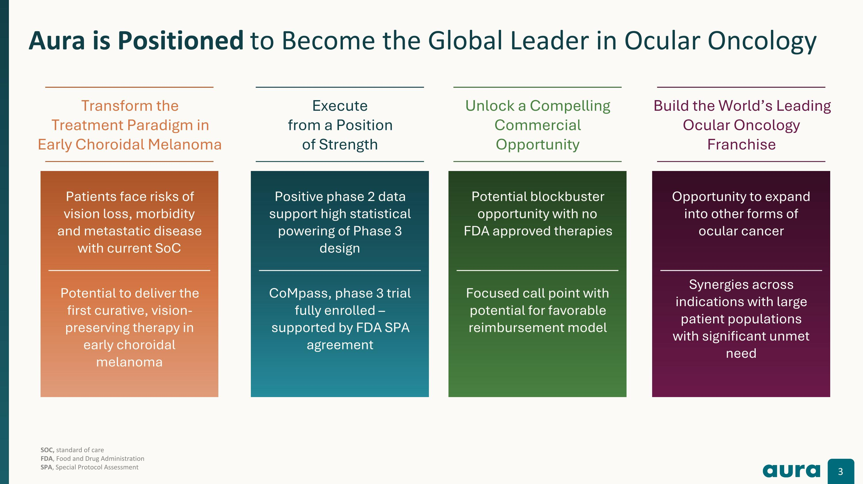
Aura is well-positioned to become the leader in ocular oncology Aura is Positioned to Become the Global Leader in Ocular Oncology Transform the Treatment Paradigm in Early Choroidal Melanoma Potential to deliver the first curative, vision-preserving therapy in early choroidal melanoma Patients face risks of vision loss, morbidity and metastatic disease with current SoC Execute from a Position of Strength CoMpass, phase 3 trial fully enrolled – supported by FDA SPA agreement Positive phase 2 data support high statistical powering of Phase 3 design Unlock a Compelling Commercial Opportunity Potential blockbuster opportunity with no FDA approved therapies Focused call point with potential for favorable reimbursement model Build the World’s Leading Ocular Oncology Franchise Synergies across indications with large patient populations with significant unmet need Opportunity to expand into other forms of ocular cancer SOC, standard of care FDA, Food and Drug Administration?SPA, Special Protocol Assessment

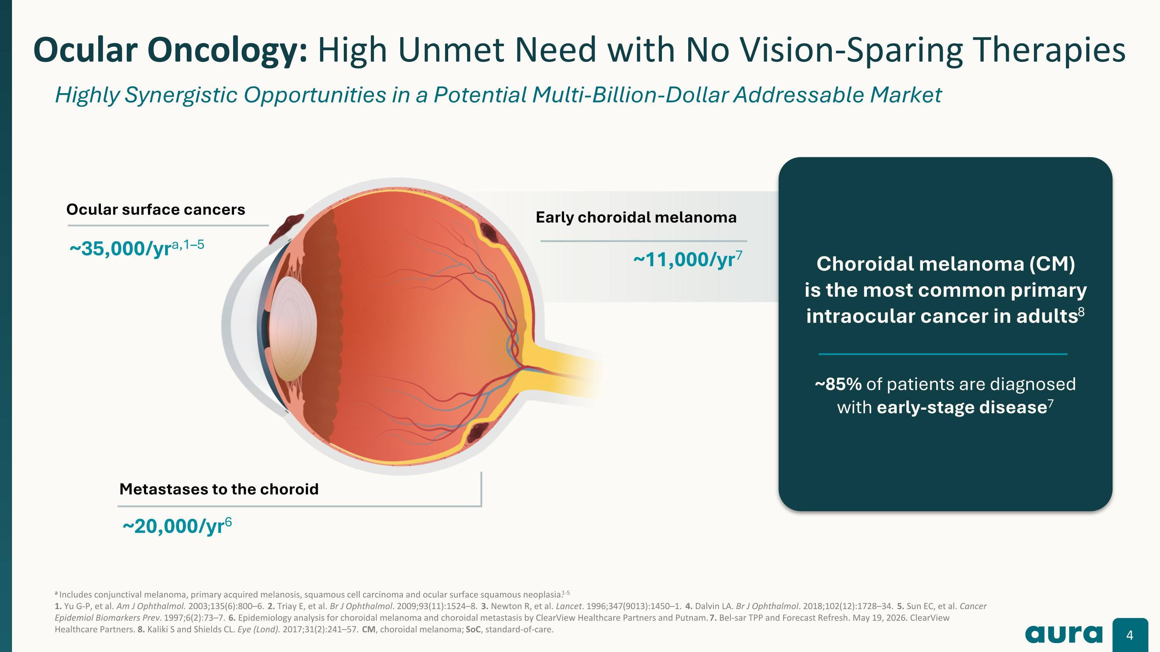
a Includes conjunctival melanoma, primary acquired melanosis, squamous cell carcinoma and ocular surface squamous neoplasia.1-5 1. Yu G-P, et al. Am J Ophthalmol. 2003;135(6):800–6. 2. Triay E, et al. Br J Ophthalmol. 2009;93(11):1524–8. 3. Newton R, et al. Lancet. 1996;347(9013):1450–1. 4. Dalvin LA. Br J Ophthalmol. 2018;102(12):1728–34. 5. Sun EC, et al. Cancer Epidemiol Biomarkers Prev. 1997;6(2):73–7. 6. Epidemiology analysis for choroidal melanoma and choroidal metastasis by ClearView Healthcare Partners and Putnam. 7. Bel-sar TPP and Forecast Refresh. May 19, 2026. ClearView Healthcare Partners. 8. Kaliki S and Shields CL. Eye (Lond). 2017;31(2):241–57. CM, choroidal melanoma; SoC, standard-of-care. Ocular Oncology: High Unmet Need with No Vision-Sparing Therapies Highly Synergistic Opportunities in a Potential Multi-Billion-Dollar Addressable Market Ocular surface cancers ~35,000/yra,1–5 Early choroidal melanoma ~11,000/yr7 Metastases to the choroid ~20,000/yr6 Choroidal melanoma (CM)?is the most common primary intraocular cancer in adults8 ~85% of patients are diagnosed with early-stage disease7

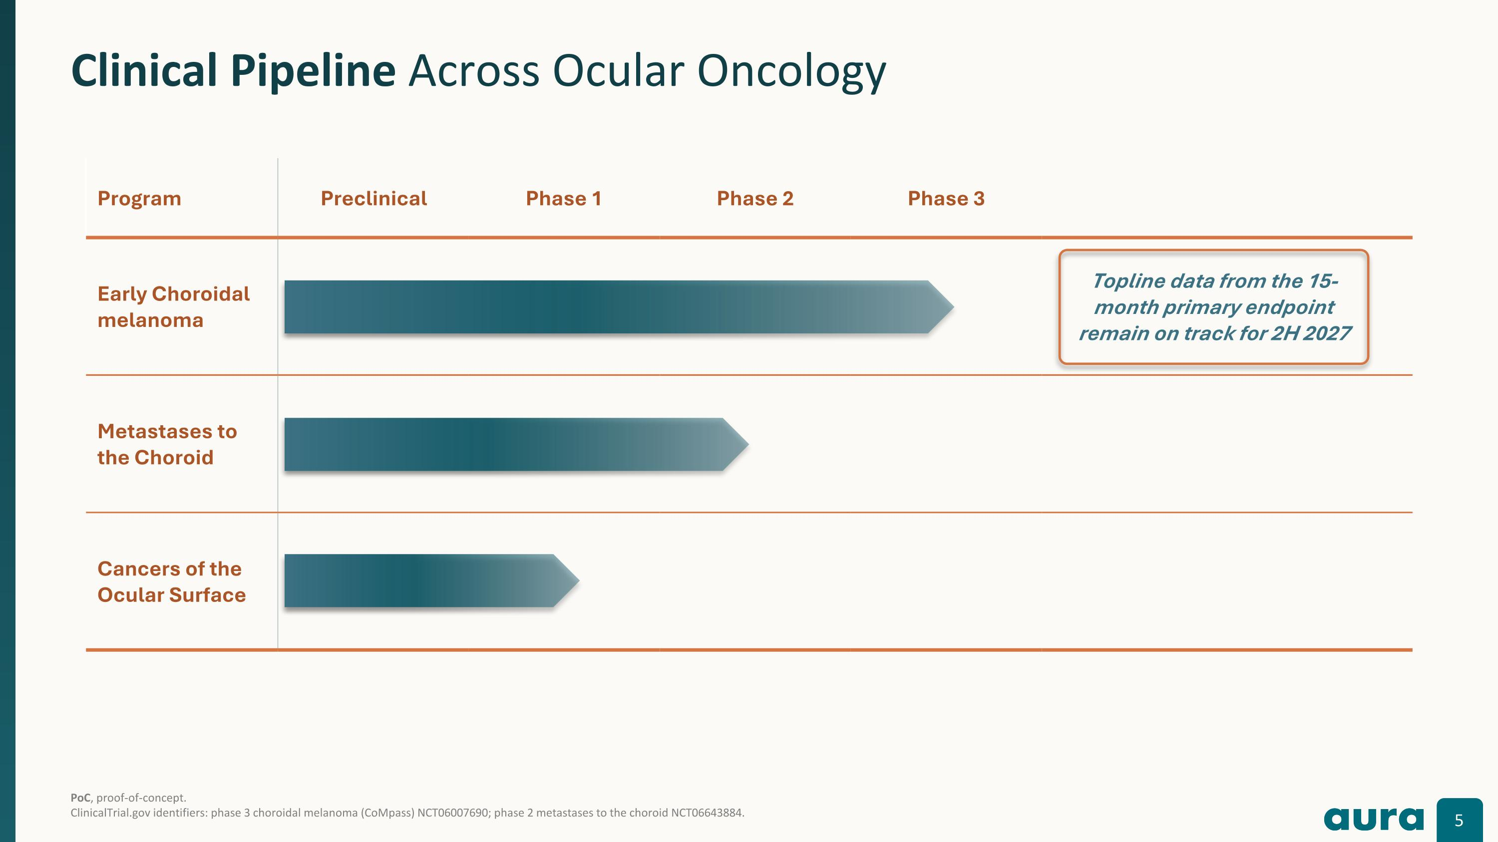
PoC, proof-of-concept.?ClinicalTrial.gov identifiers: phase 3 choroidal melanoma (CoMpass) NCT06007690; phase 2 metastases to the choroid NCT06643884. Clinical Pipeline Across Ocular Oncology Program Preclinical Phase 1 Phase 2 Phase 3 Early Choroidal melanoma Metastases to?the Choroid Cancers of the?Ocular Surface Topline data from the 15-month primary endpoint remain on track for 2H 2027

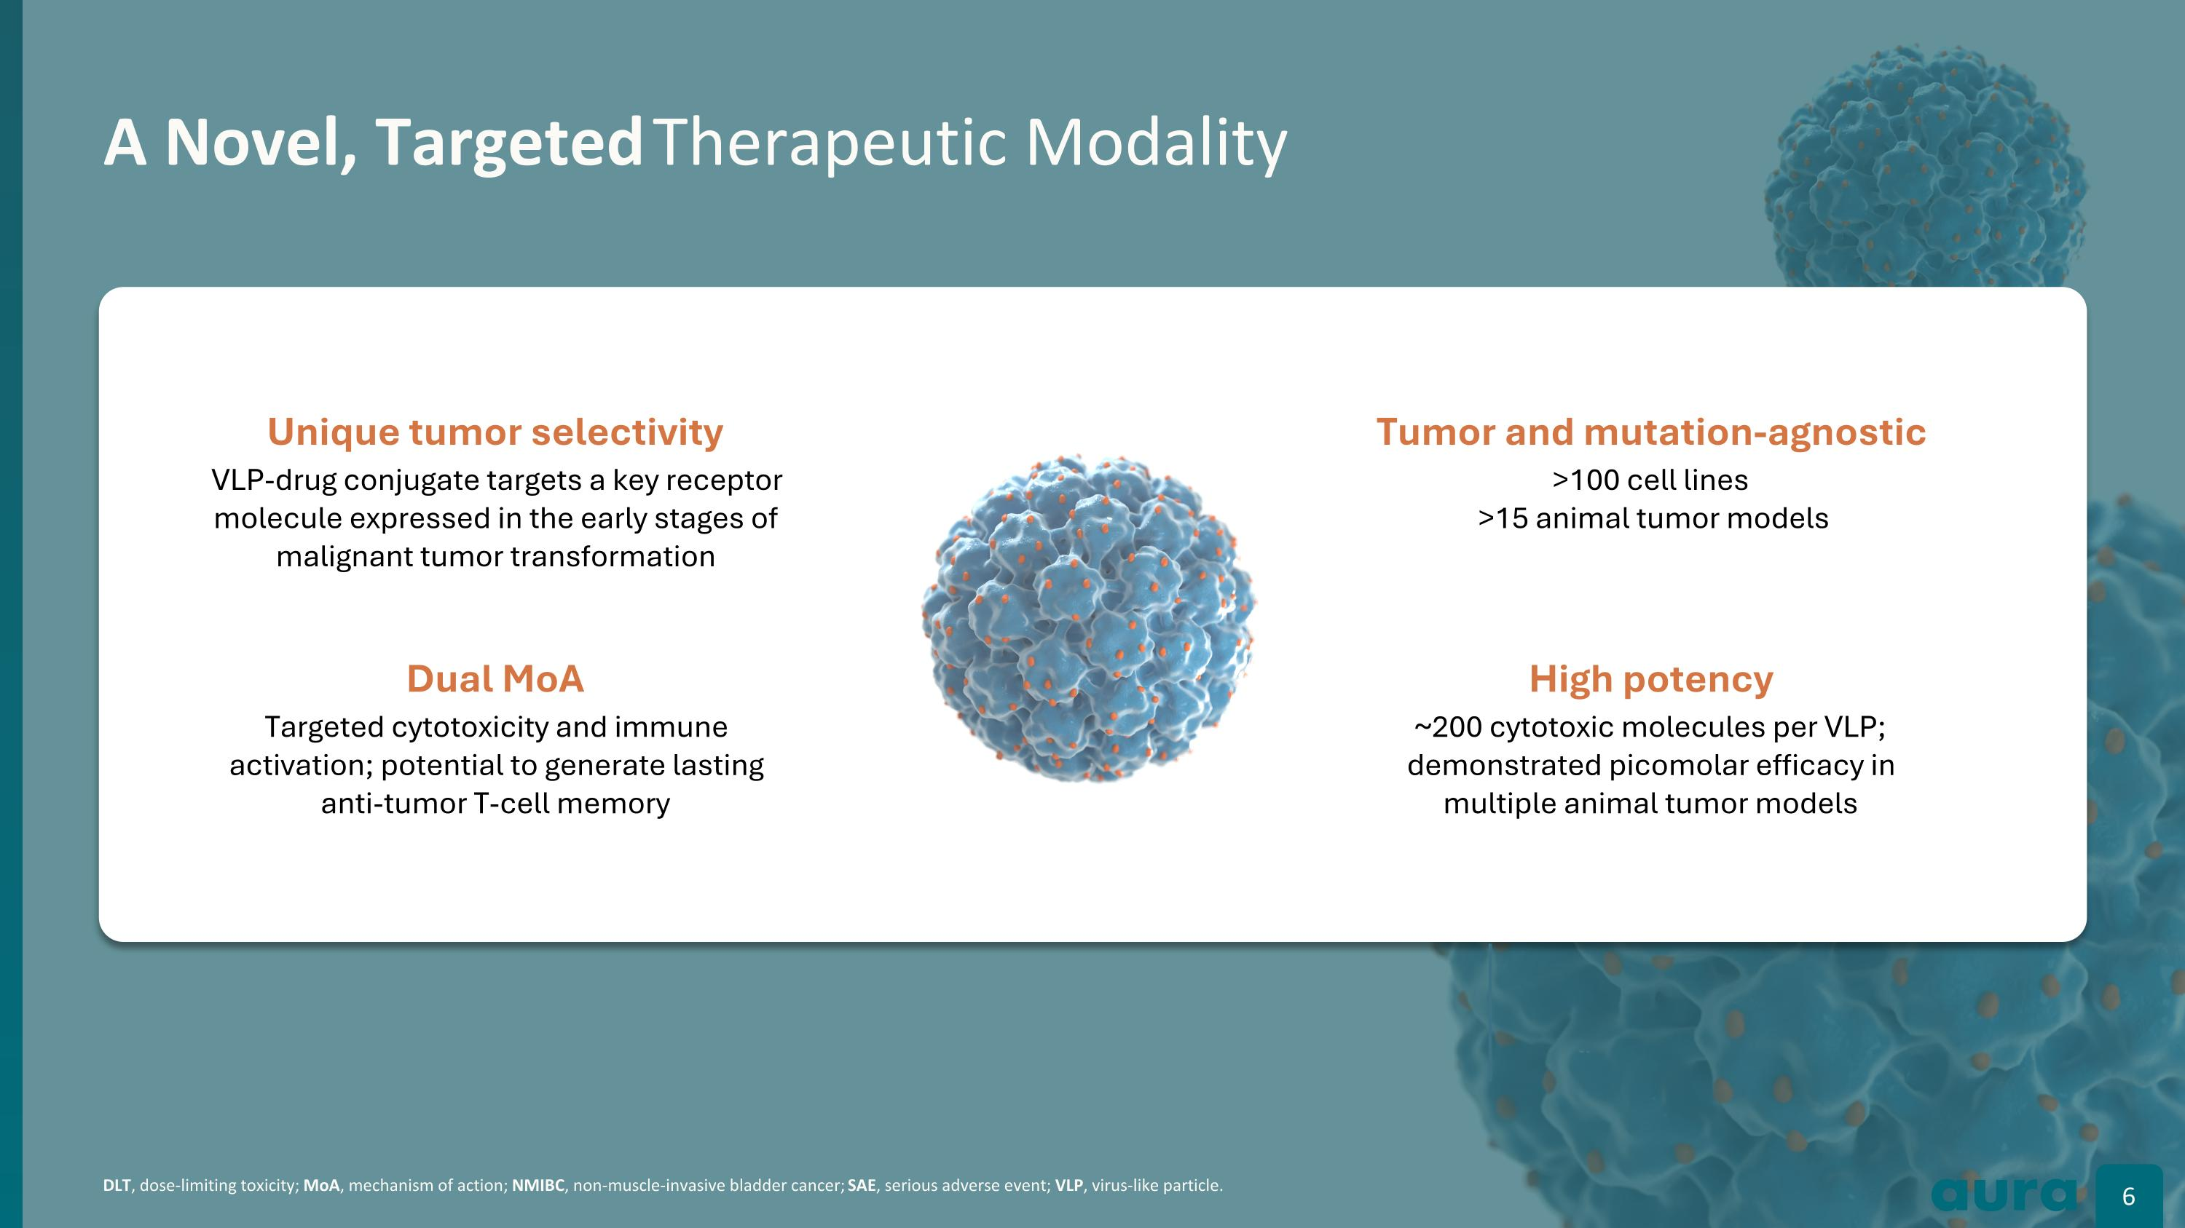
DLT, dose-limiting toxicity; MoA, mechanism of action; NMIBC, non-muscle-invasive bladder cancer; SAE, serious adverse event; VLP, virus-like particle. A Novel, Targeted Therapeutic Modality Unique tumor selectivity VLP-drug conjugate targets a key receptor molecule expressed in the early stages of malignant tumor transformation Dual MoA Targeted cytotoxicity and immune activation; potential to generate lasting anti-tumor T-cell memory Tumor and mutation-agnostic >100 cell lines? >15 animal tumor models High potency ~200 cytotoxic molecules per VLP; demonstrated picomolar efficacy in multiple animal tumor models

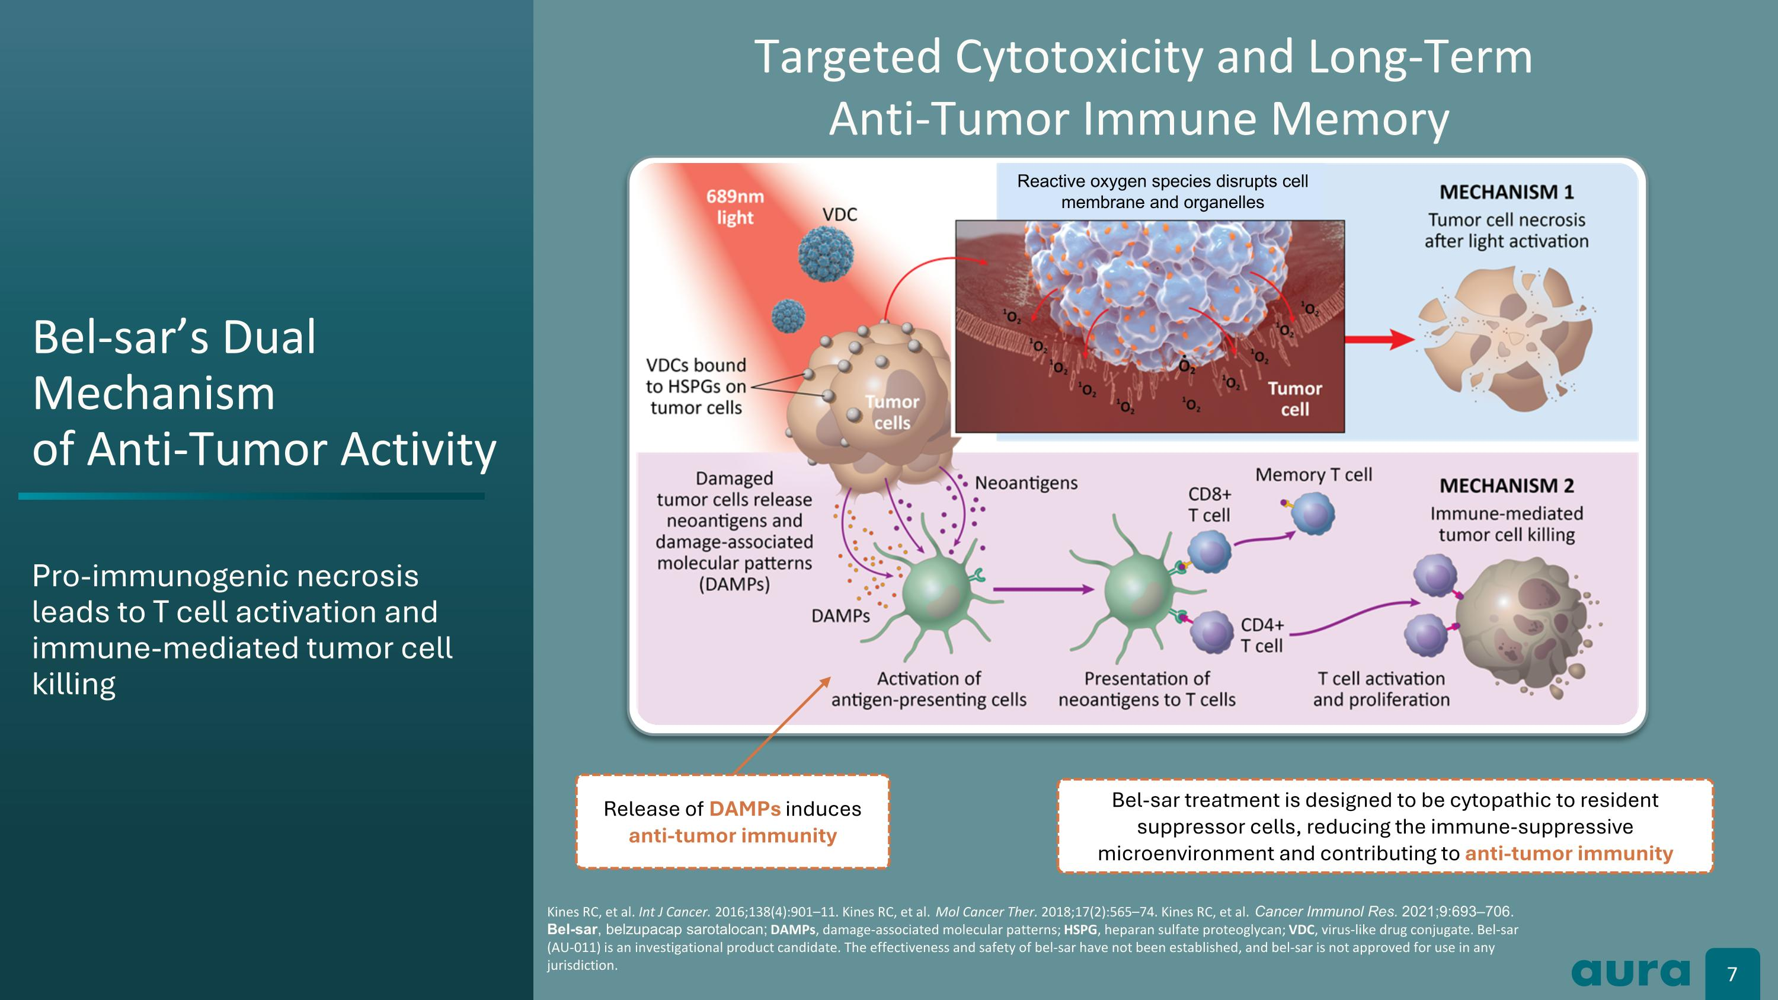
Bel-sar’s Dual Mechanism?of Anti-Tumor Activity Pro-immunogenic necrosis?leads to T cell activation and immune-mediated tumor cell killing Kines RC, et al. Int J Cancer. 2016;138(4):901–11. Kines RC, et al. Mol Cancer Ther. 2018;17(2):565–74. Kines RC, et al. Cancer Immunol Res. 2021;9:693–706. ?Bel-sar, belzupacap sarotalocan; DAMPs, damage-associated molecular patterns; HSPG, heparan sulfate proteoglycan; VDC, virus-like drug conjugate. Bel-sar (AU-011) is an investigational product candidate. The effectiveness and safety of bel-sar have not been established, and bel-sar is not approved for use in any jurisdiction. Release of DAMPs induces anti-tumor immunity Bel-sar treatment is designed to be cytopathic to resident suppressor cells, reducing the immune-suppressive microenvironment and contributing to anti-tumor immunity Reactive oxygen species disrupts cell ?membrane and organelles Targeted Cytotoxicity and Long-Term Anti-Tumor Immune Memory

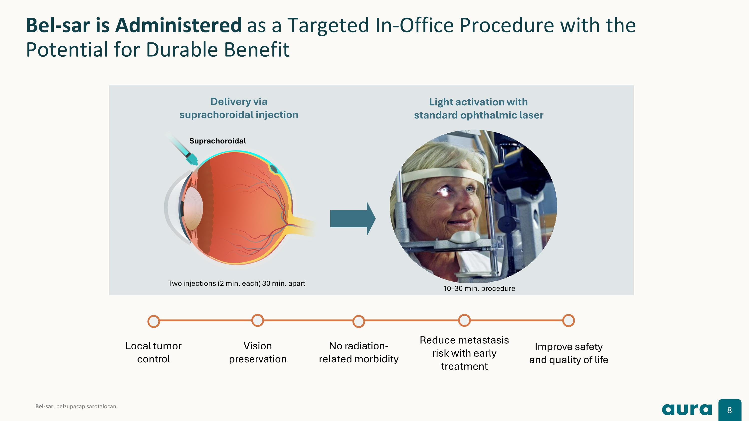
Bel-sar is Administered as a Targeted In-Office Procedure with the Potential for Durable Benefit Bel-sar, belzupacap sarotalocan. No radiation-?related morbidity Vision?preservation Local tumor control Reduce metastasis?risk with early treatment Improve safety?and quality of life Two injections (2 min. each) 30 min. apart 10–30 min. procedure Delivery via?suprachoroidal injection Light activation with standard ophthalmic laser Suprachoroidal

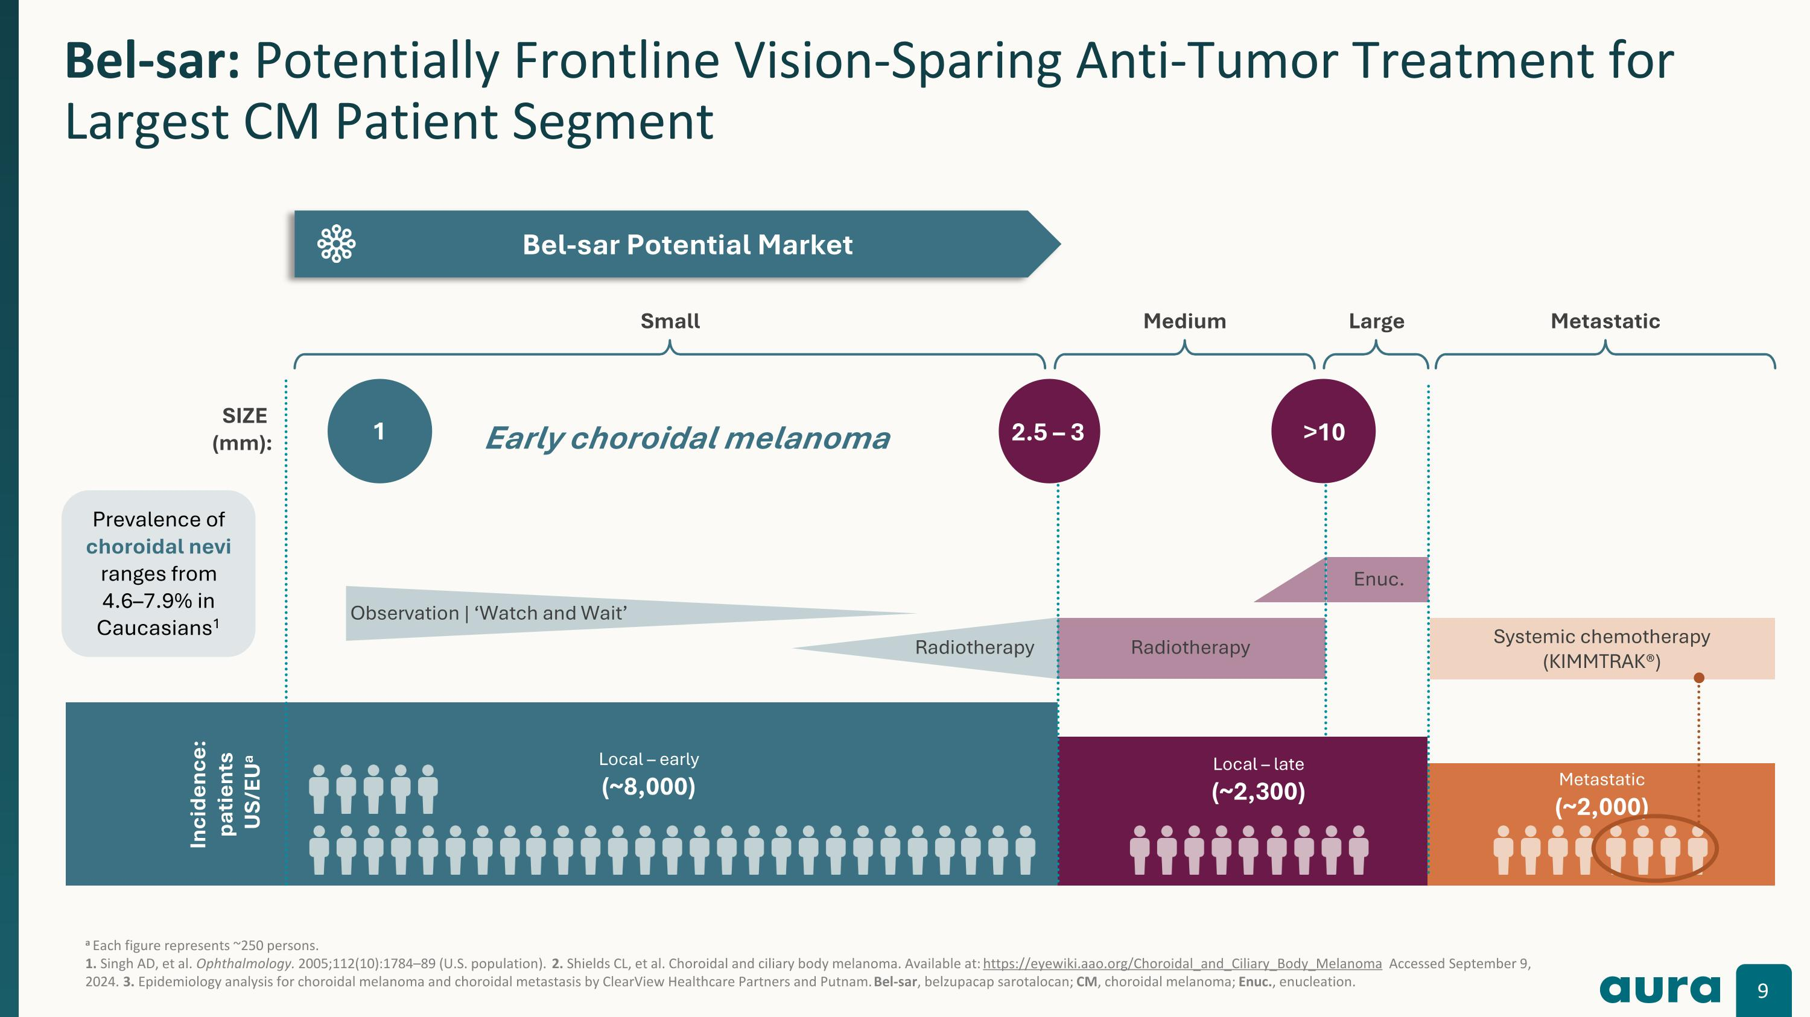
a Each figure represents ~250 persons. 1. Singh AD, et al. Ophthalmology. 2005;112(10):1784–89 (U.S. population). 2. Shields CL, et al. Choroidal and ciliary body melanoma. Available at: https://eyewiki.aao.org/Choroidal_and_Ciliary_Body_Melanoma Accessed September 9, 2024. 3. Epidemiology analysis for choroidal melanoma and choroidal metastasis by ClearView Healthcare Partners and Putnam. Bel-sar, belzupacap sarotalocan; CM, choroidal melanoma; Enuc., enucleation. Bel-sar: Potentially Frontline Vision-Sparing Anti-Tumor Treatment for Largest CM Patient Segment Observation | ‘Watch and Wait’ Incidence: patients? US/EUa Local – early (~8,000) Local – late (~2,300) Metastatic (~2,000) SIZE ?(mm): Small Medium Large Metastatic Radiotherapy Radiotherapy 1 2.5 – 3 >10 Enuc. Systemic chemotherapy (KIMMTRAK®) Prevalence of choroidal nevi ranges from 4.6–7.9% in Caucasians1 Early choroidal melanoma Bel-sar Potential Market

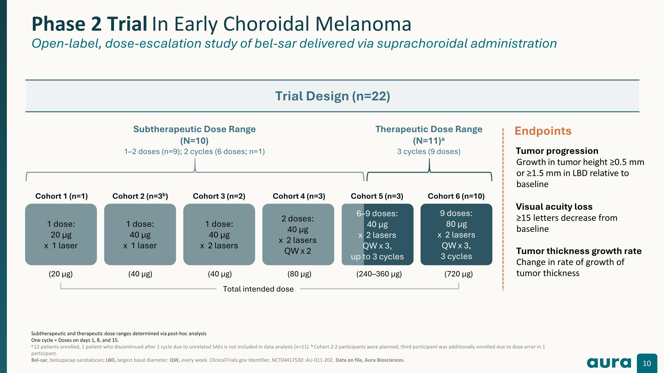
Subtherapeutic and therapeutic dose ranges determined via post-hoc analysis One cycle = Doses on days 1, 8, and 15. a 12 patients enrolled, 1 patient who discontinued after 1 cycle due to unrelated SAEs is not included in data analysis (n=11). b Cohort 2:2 participants were planned; third participant was additionally enrolled due to dose error in 1 participant.?Bel-sar, belzupacap sarotalocan; LBD, largest basal diameter; QW, every week. ClinicalTrials.gov Identifier, NCT04417530: AU-011-202. Data on file, Aura Biosciences. Phase 2 Trial In Early Choroidal Melanoma ?Open-label, dose-escalation study of bel-sar delivered via suprachoroidal administration Trial Design (n=22) Endpoints Tumor progression Growth in tumor height ≥0.5 mm or ≥1.5 mm in LBD relative to baseline Visual acuity loss ≥15 letters decrease from baseline Tumor thickness growth rate Change in rate of growth of tumor thickness 1 dose:?20 μg x 1 laser 1 dose:?40 μg x 1 laser 1 dose:?40 μg x 2 lasers 2 doses:?40 μg x 2 lasers QW x 2 9 doses:?80 μg x 2 lasers QW x 3,?3 cycles Subtherapeutic Dose Range?(N=10) 1–2 doses (n=9); 2 cycles (6 doses; n=1) Therapeutic Dose Range?(N=11)a 3 cycles (9 doses) Cohort 1 (n=1) Cohort 2 (n=3b) Cohort 3 (n=2) Cohort 4 (n=3) Cohort 5 (n=3) Cohort 6 (n=10) 6–9 doses:?40 μg x 2 lasers QW x 3,?up to 3 cycles (20 µg) (40 µg) (40 µg) (80 µg) (240–360 µg) (720 µg) Total intended dose

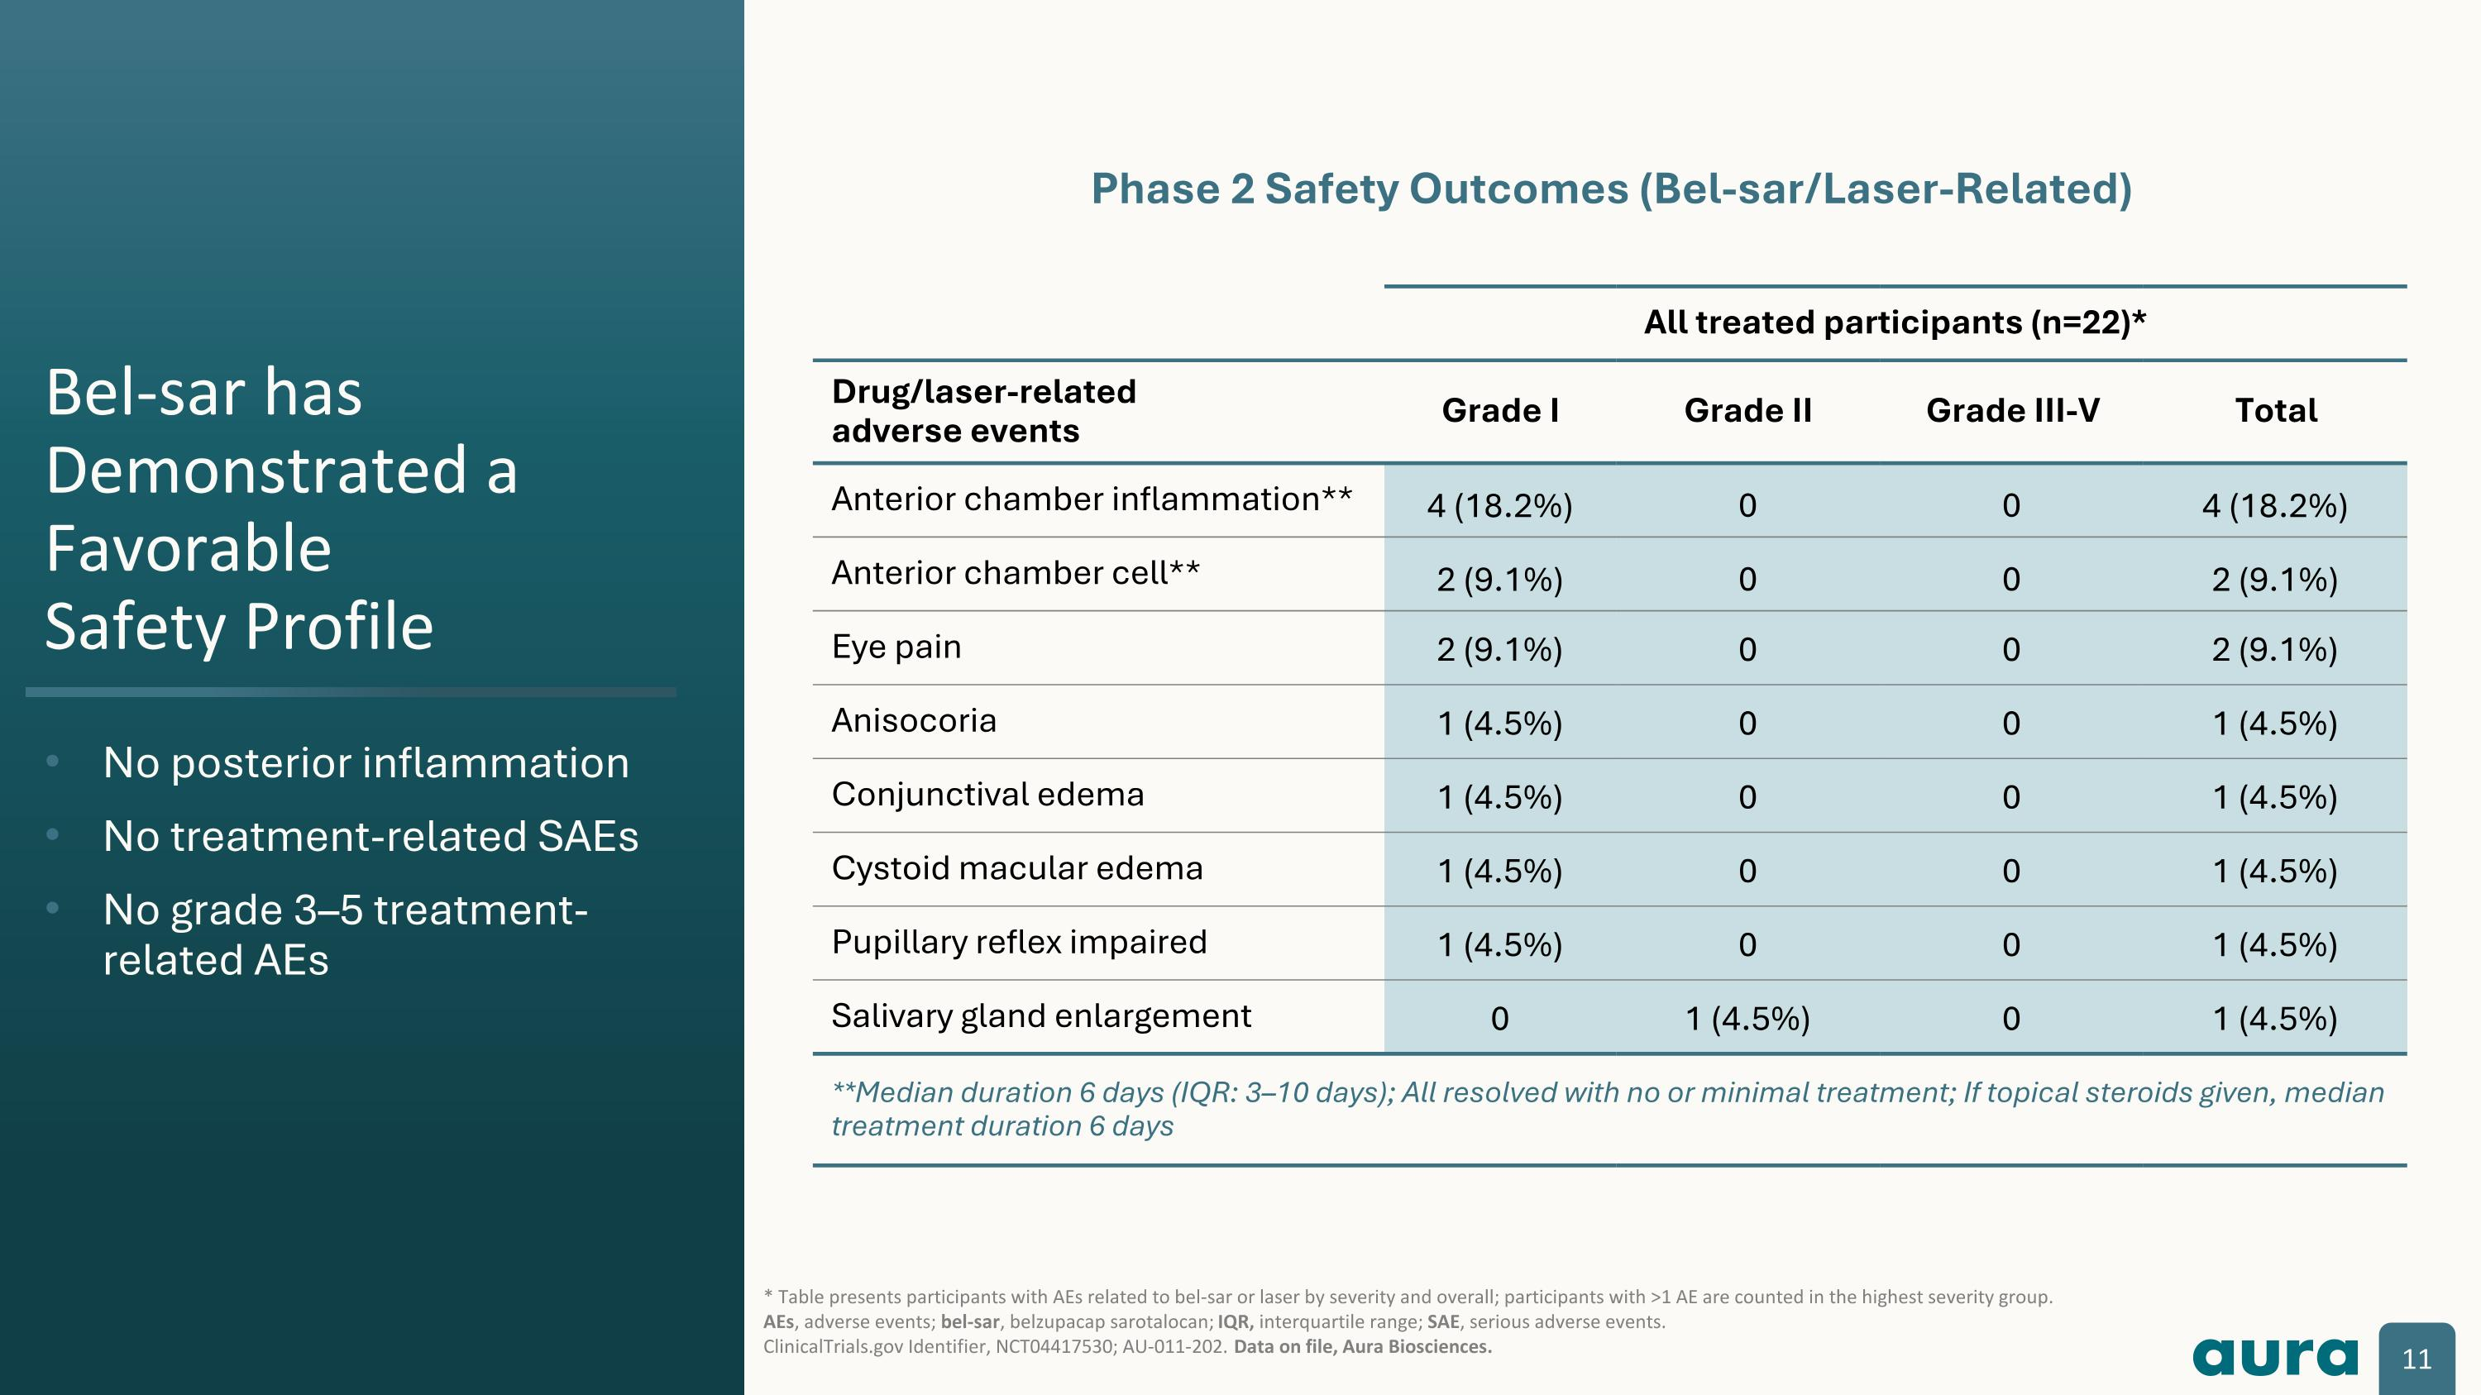
Bel-sar has Demonstrated a Favorable?Safety Profile No posterior inflammation No treatment-related SAEs No grade 3–5 treatment-related AEs * Table presents participants with AEs related to bel-sar or laser by severity and overall; participants with >1 AE are counted in the highest severity group.?AEs, adverse events; bel-sar, belzupacap sarotalocan; IQR, interquartile range; SAE, serious adverse events.?ClinicalTrials.gov Identifier, NCT04417530; AU-011-202. Data on file, Aura Biosciences. All treated participants (n=22)* Drug/laser-related?adverse events Grade I Grade II Grade III-V Total Anterior chamber inflammation** 4 (18.2%) 0 0 4 (18.2%) Anterior chamber cell** 2 (9.1%) 0 0 2 (9.1%) Eye pain 2 (9.1%) 0 0 2 (9.1%) Anisocoria 1 (4.5%) 0 0 1 (4.5%) Conjunctival edema 1 (4.5%) 0 0 1 (4.5%) Cystoid macular edema 1 (4.5%) 0 0 1 (4.5%) Pupillary reflex impaired 1 (4.5%) 0 0 1 (4.5%) Salivary gland enlargement 0 1 (4.5%) 0 1 (4.5%) **Median duration 6 days (IQR: 3–10 days); All resolved with no or minimal treatment; If topical steroids given, median treatment duration 6 days Phase 2 Safety Outcomes (Bel-sar/Laser-Related)

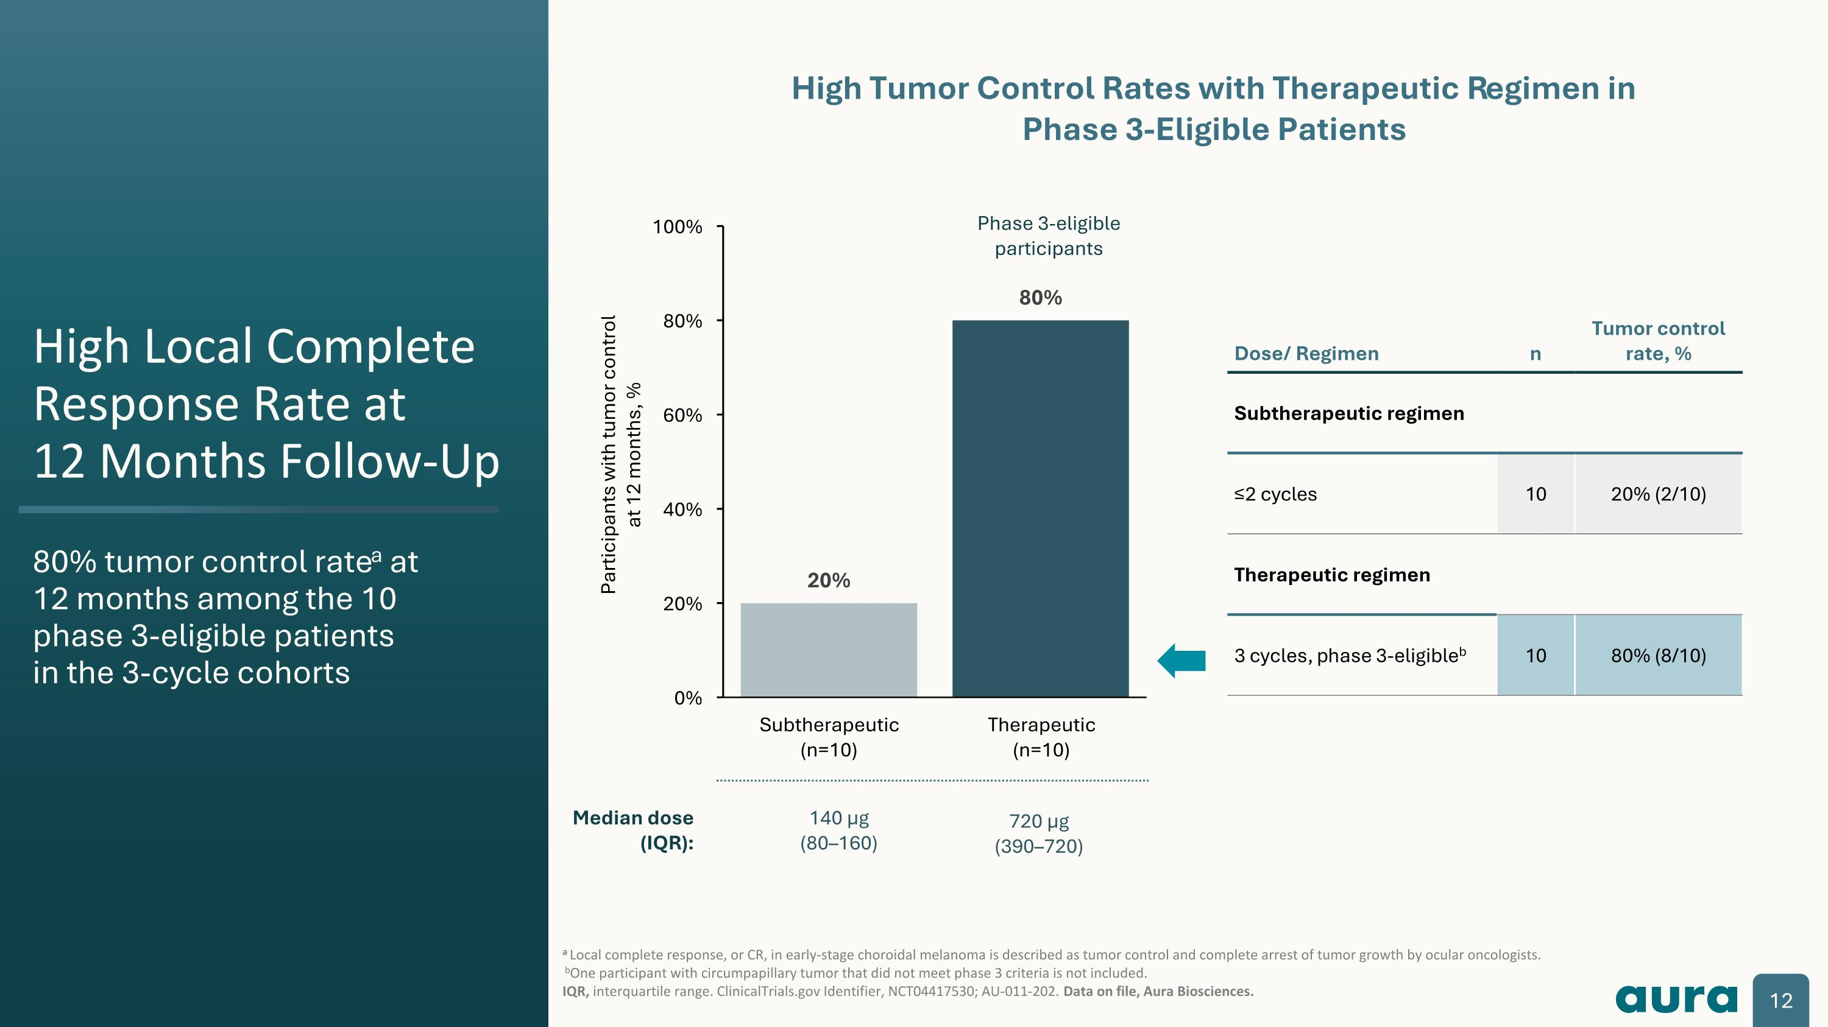
High Local Complete Response Rate at ?12 Months Follow-Up 80% tumor control ratea at?12 months among the 10?phase 3-eligible patients?in the 3-cycle cohorts a Local complete response, or CR, in early-stage choroidal melanoma is described as tumor control and complete arrest of tumor growth by ocular oncologists. bOne participant with circumpapillary tumor that did not meet phase 3 criteria is not included.?IQR, interquartile range. ClinicalTrials.gov Identifier, NCT04417530; AU-011-202. Data on file, Aura Biosciences. Participants with tumor control at 12 months, % Dose/ Regimen n Tumor control rate, % Subtherapeutic regimen ≤2 cycles 10 20% (2/10) Therapeutic regimen 3 cycles, phase 3-eligibleb 10 80% (8/10) Phase 3-eligible participants High Tumor Control Rates with Therapeutic Regimen in?Phase 3-Eligible Patients Median dose (IQR): 720 µg?(390–720) 140 µg?(80–160)

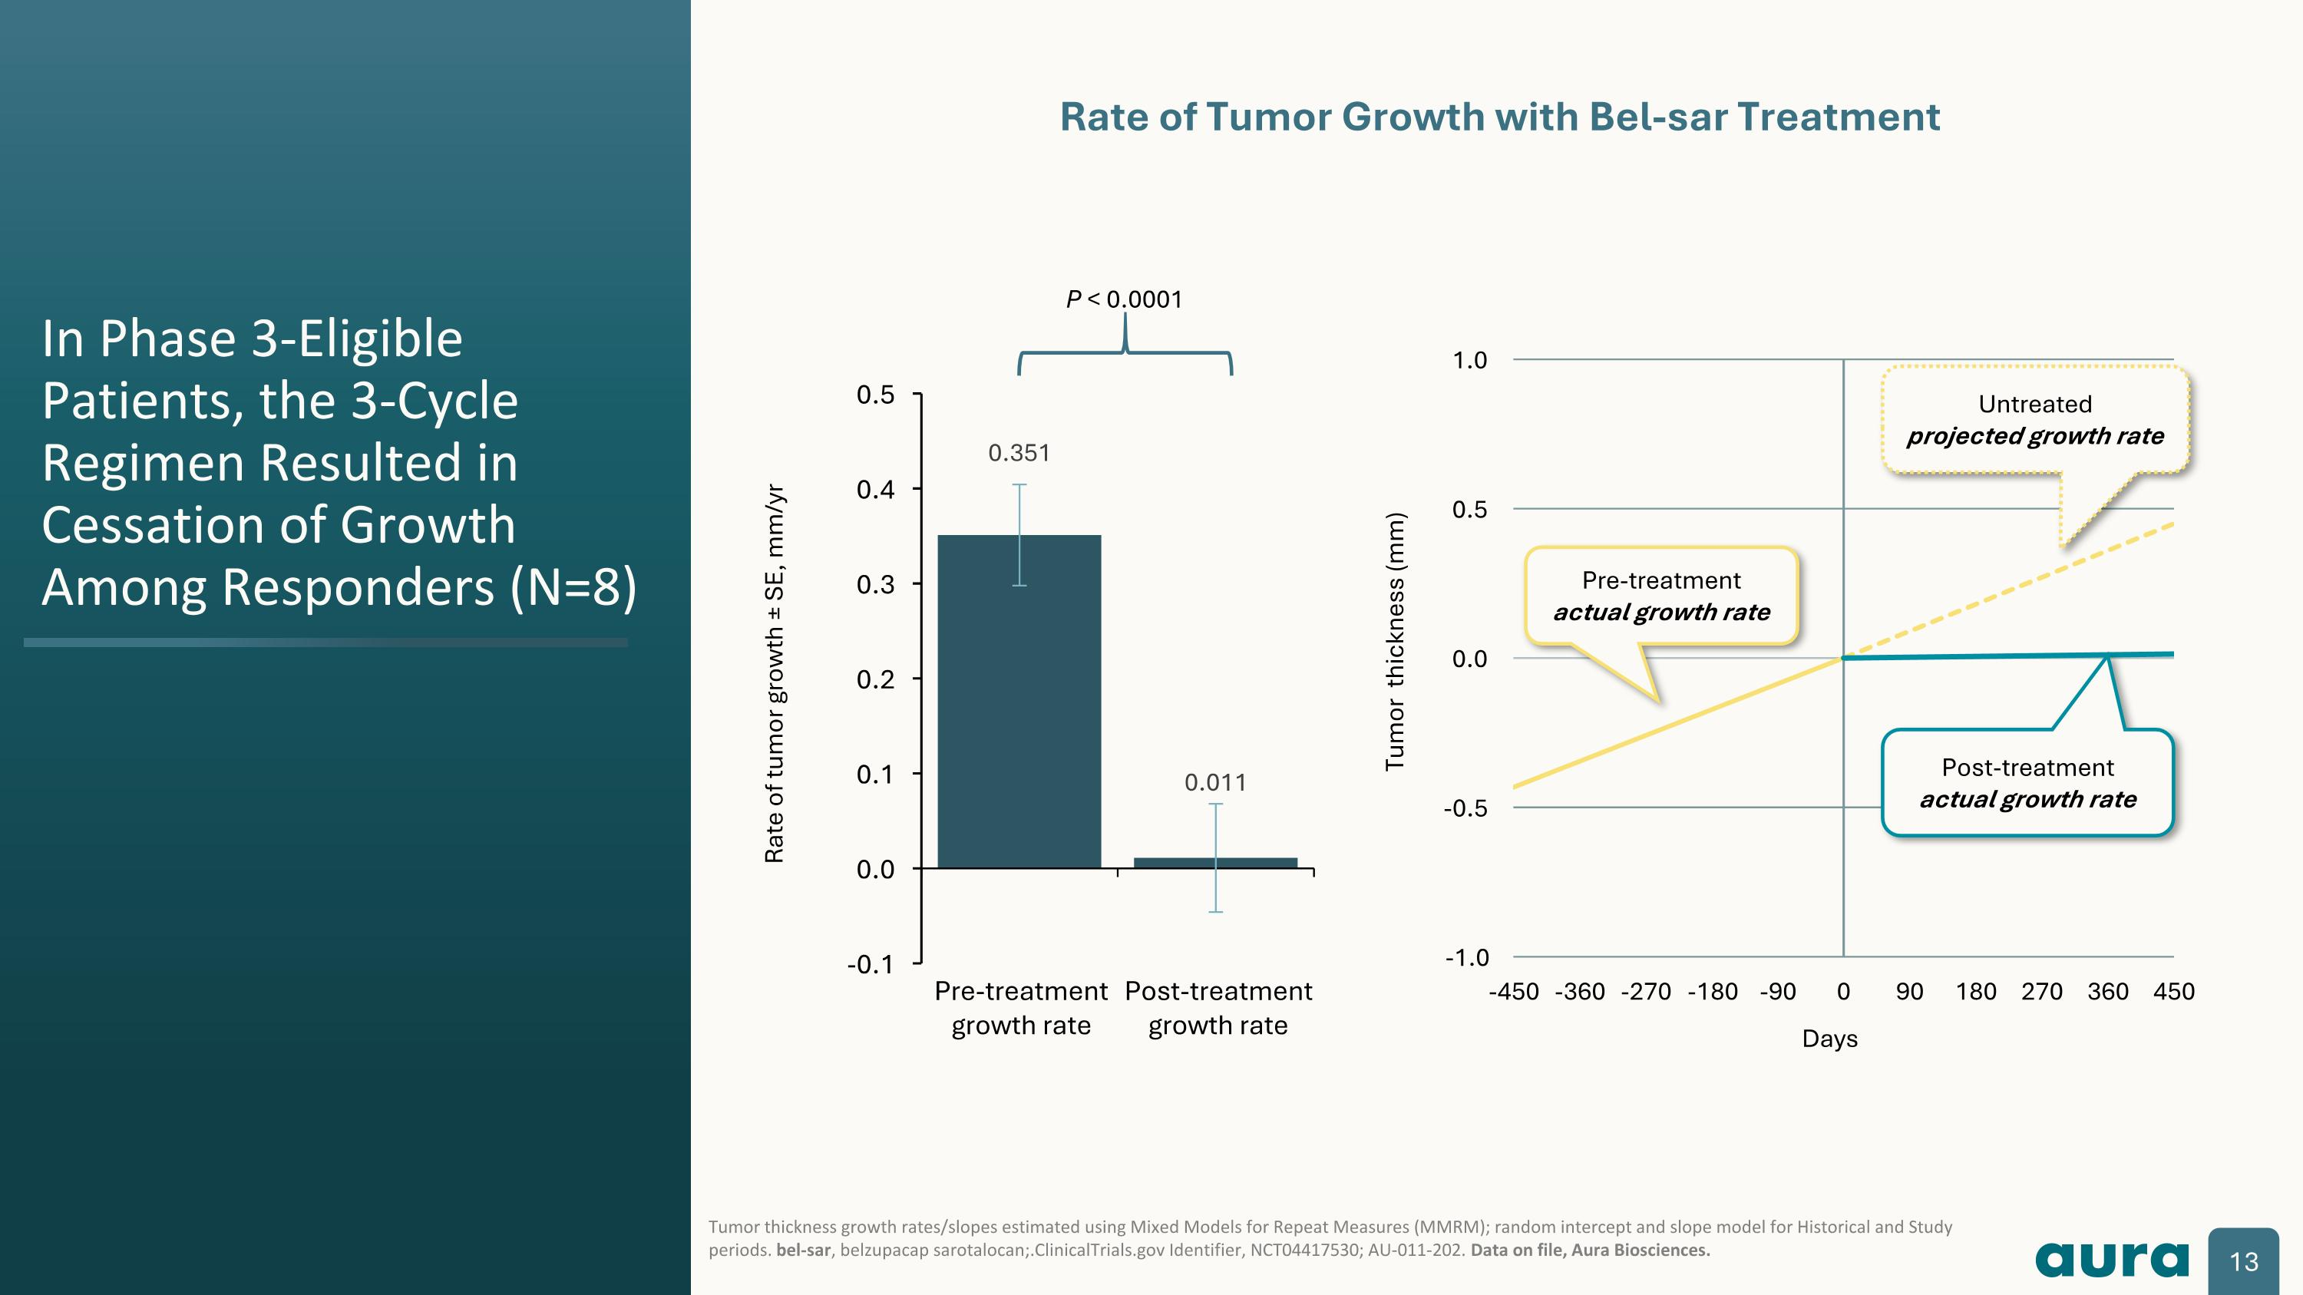
Rate of tumor growth ± SE, mm/yr P < 0.0001 Rate of Tumor Growth with Bel-sar Treatment In Phase 3-Eligible Patients, the 3-Cycle Regimen Resulted in Cessation of Growth Among Responders (N=8) Tumor thickness growth rates/slopes estimated using Mixed Models for Repeat Measures (MMRM); random intercept and slope model for Historical and Study periods. bel-sar, belzupacap sarotalocan;.ClinicalTrials.gov Identifier, NCT04417530; AU-011-202. Data on file, Aura Biosciences. Post-treatment actual growth rate Untreated projected growth rate Pre-treatment actual growth rate

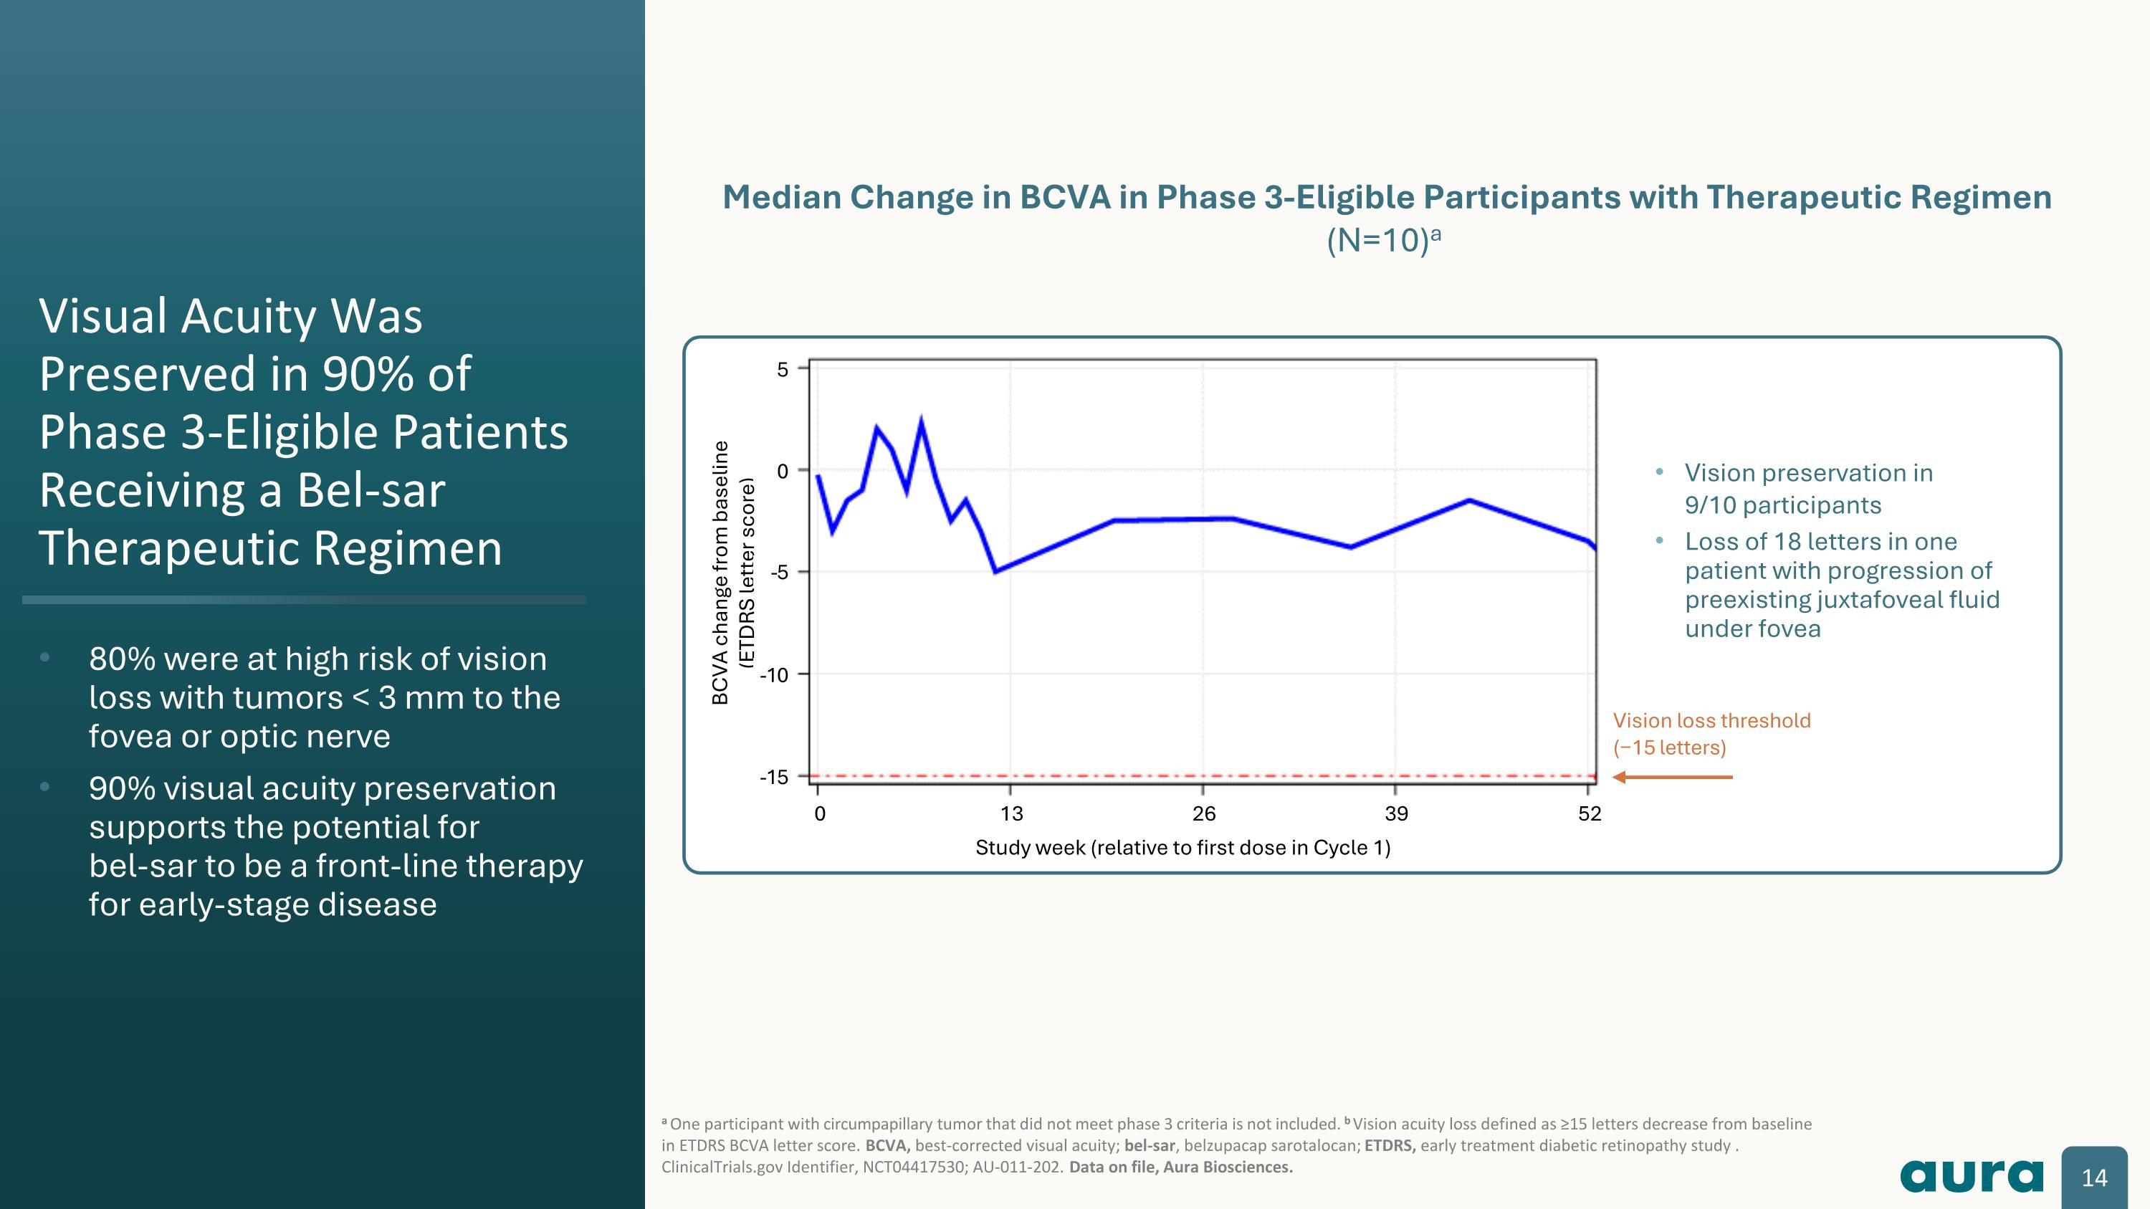
Median Change in BCVA in Phase 3-Eligible Participants with Therapeutic Regimen (N=10)a Visual Acuity Was Preserved in 90% of Phase 3-Eligible Patients Receiving a Bel-sar Therapeutic Regimen 80% were at high risk of vision loss with tumors < 3 mm to the fovea or optic nerve 90% visual acuity preservation supports the potential for?bel-sar to be a front-line therapy for early-stage disease a One participant with circumpapillary tumor that did not meet phase 3 criteria is not included. b Vision acuity loss defined as ≥15 letters decrease from baseline in ETDRS BCVA letter score. BCVA, best-corrected visual acuity; bel-sar, belzupacap sarotalocan; ETDRS, early treatment diabetic retinopathy study . ClinicalTrials.gov Identifier, NCT04417530; AU-011-202. Data on file, Aura Biosciences. Vision loss threshold?(−15 letters) BCVA change from baseline?(ETDRS letter score) Study week (relative to first dose in Cycle 1) Vision preservation in?9/10 participants Loss of 18 letters in one patient with progression of preexisting juxtafoveal fluid under fovea -5 0 5 -5 -10 -15 0 13 26 39 52

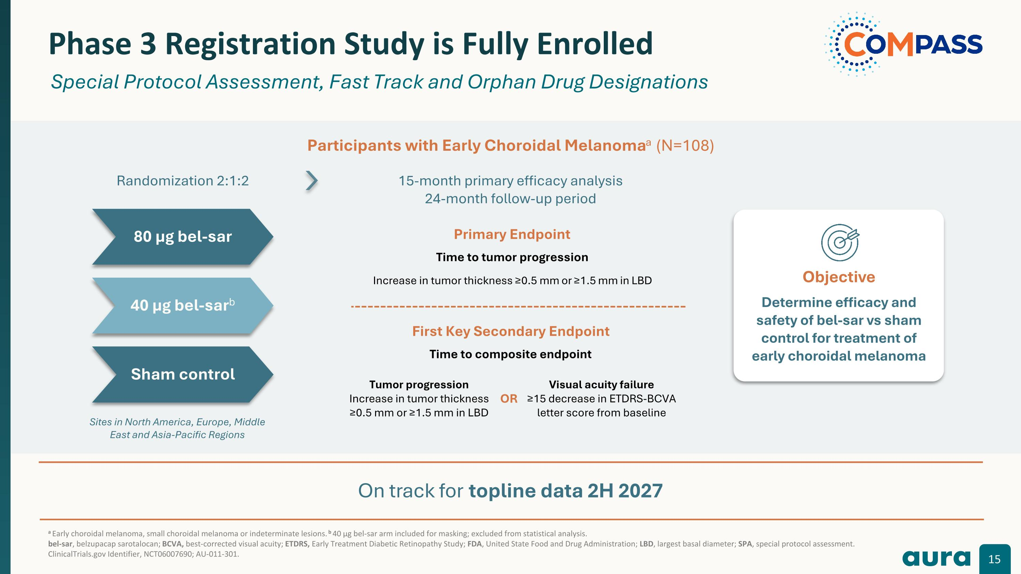
a Early choroidal melanoma, small choroidal melanoma or indeterminate lesions. b 40 µg bel-sar arm included for masking; excluded from statistical analysis. bel-sar, belzupacap sarotalocan; BCVA, best-corrected visual acuity; ETDRS, Early Treatment Diabetic Retinopathy Study; FDA, United State Food and Drug Administration; LBD, largest basal diameter; SPA, special protocol assessment.?ClinicalTrials.gov Identifier, NCT06007690; AU-011-301. Phase 3 Registration Study is Fully Enrolled Special Protocol Assessment, Fast Track and Orphan Drug Designations 80 µg bel-sar 40 µg bel-sarb Sham control Participants with Early Choroidal Melanomaa (N=108) Sites in North America, Europe, Middle East and Asia-Pacific Regions Randomization 2:1:2 15-month primary efficacy analysis 24-month follow-up period First Key Secondary Endpoint Time to composite endpoint Primary Endpoint Time to tumor progression Increase in tumor thickness ≥0.5 mm or ≥1.5 mm in LBD Tumor progression?Increase in tumor thickness ≥0.5 mm or ≥1.5 mm in LBD Visual acuity failure?≥15 decrease in ETDRS-BCVA letter score from baseline OR Objective Determine efficacy and safety of bel-sar vs sham control for treatment of early choroidal melanoma On track for topline data 2H 2027

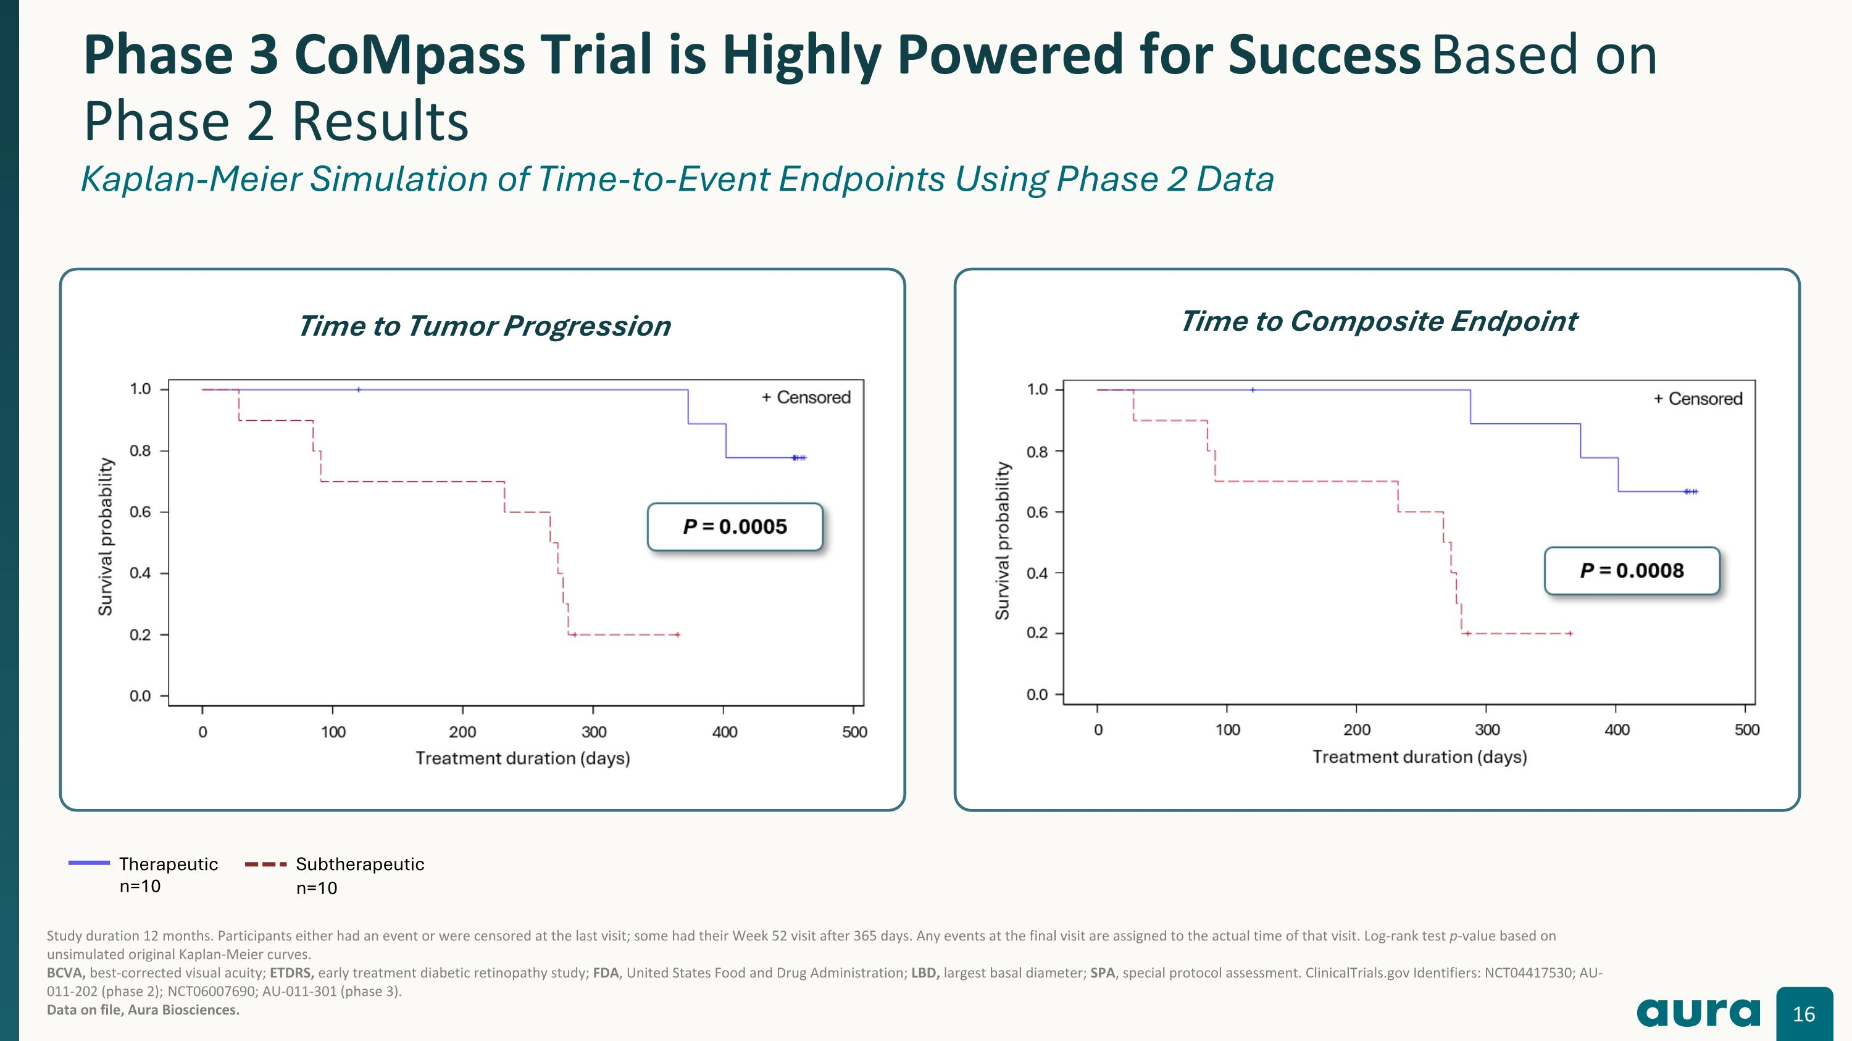
Phase 3 CoMpass Trial is Highly Powered for Success Based on Phase 2 Results Kaplan-Meier Simulation of Time-to-Event Endpoints Using Phase 2 Data Study duration 12 months. Participants either had an event or were censored at the last visit; some had their Week 52 visit after 365 days. Any events at the final visit are assigned to the actual time of that visit. Log-rank test p-value based on unsimulated original Kaplan-Meier curves.?BCVA, best-corrected visual acuity; ETDRS, early treatment diabetic retinopathy study; FDA, United States Food and Drug Administration; LBD, largest basal diameter; SPA, special protocol assessment. ClinicalTrials.gov Identifiers: NCT04417530; AU-011-202 (phase 2); NCT06007690; AU-011-301 (phase 3).?Data on file, Aura Biosciences. Therapeutic?n=10 Subtherapeutic n=10 Time to Tumor Progression Time to Composite Endpoint

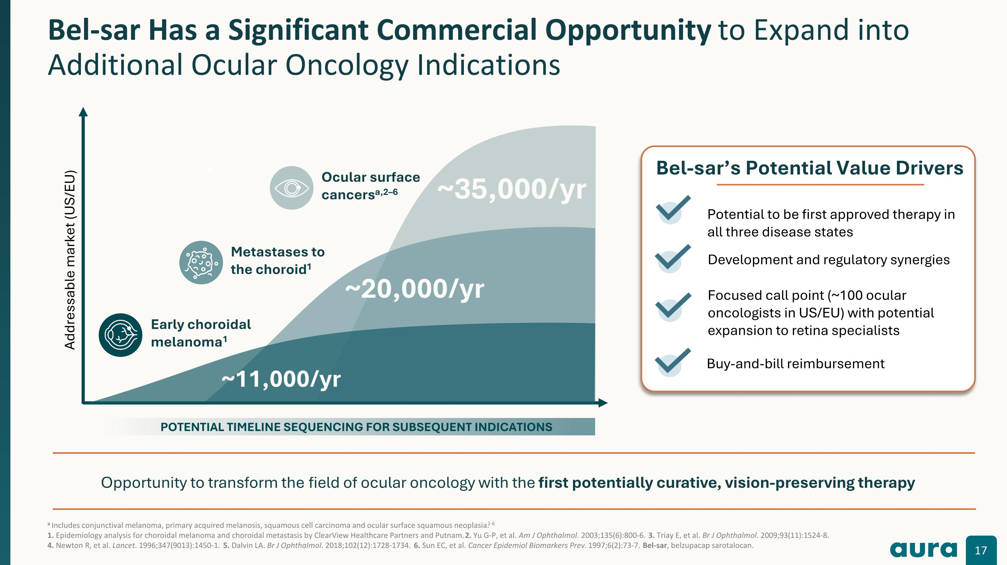
a Includes conjunctival melanoma, primary acquired melanosis, squamous cell carcinoma and ocular surface squamous neoplasia.2-6 1. Epidemiology analysis for choroidal melanoma and choroidal metastasis by ClearView Healthcare Partners and Putnam. 2. Yu G-P, et al. Am J Ophthalmol. 2003;135(6):800-6. 3. Triay E, et al. Br J Ophthalmol. 2009;93(11):1524-8. ?4. Newton R, et al. Lancet. 1996;347(9013):1450-1. 5. Dalvin LA. Br J Ophthalmol. 2018;102(12):1728-1734. 6. Sun EC, et al. Cancer Epidemiol Biomarkers Prev. 1997;6(2):73-7. Bel-sar, belzupacap sarotalocan. Bel-sar Has a Significant Commercial Opportunity to Expand into Additional Ocular Oncology Indications ~35,000/yr Opportunity to transform the field of ocular oncology with the first potentially curative, vision-preserving therapy Addressable market (US/EU) ~20,000/yr Early choroidal melanoma1 Metastases to the choroid1 POTENTIAL TIMELINE SEQUENCING FOR SUBSEQUENT INDICATIONS ~11,000/yr Bel-sar’s Potential Value Drivers Potential to be first approved therapy in all three disease states Development and regulatory synergies Focused call point (~100 ocular oncologists in US/EU) with potential expansion to retina specialists Buy-and-bill reimbursement Ocular surface cancersa,2–6

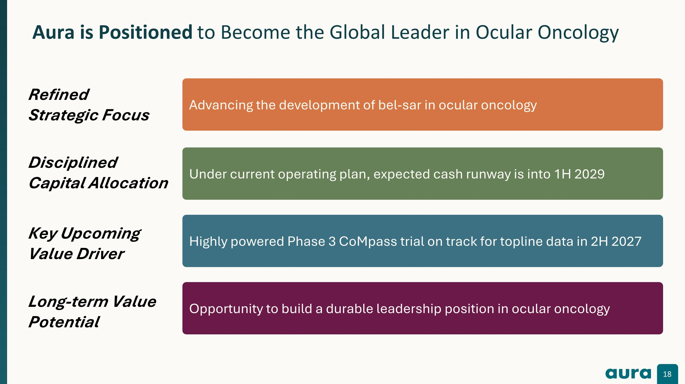
Aura is well-positioned to become the leader in ocular oncology Aura is Positioned to Become the Global Leader in Ocular Oncology Advancing the development of bel-sar in ocular oncology Under current operating plan, expected cash runway is into 1H 2029 Opportunity to build a durable leadership position in ocular oncology Highly powered Phase 3 CoMpass trial on track for topline data in 2H 2027 Refined ?Strategic Focus Key Upcoming ?Value Driver Disciplined ?Capital Allocation Long-term Value Potential


Appendix

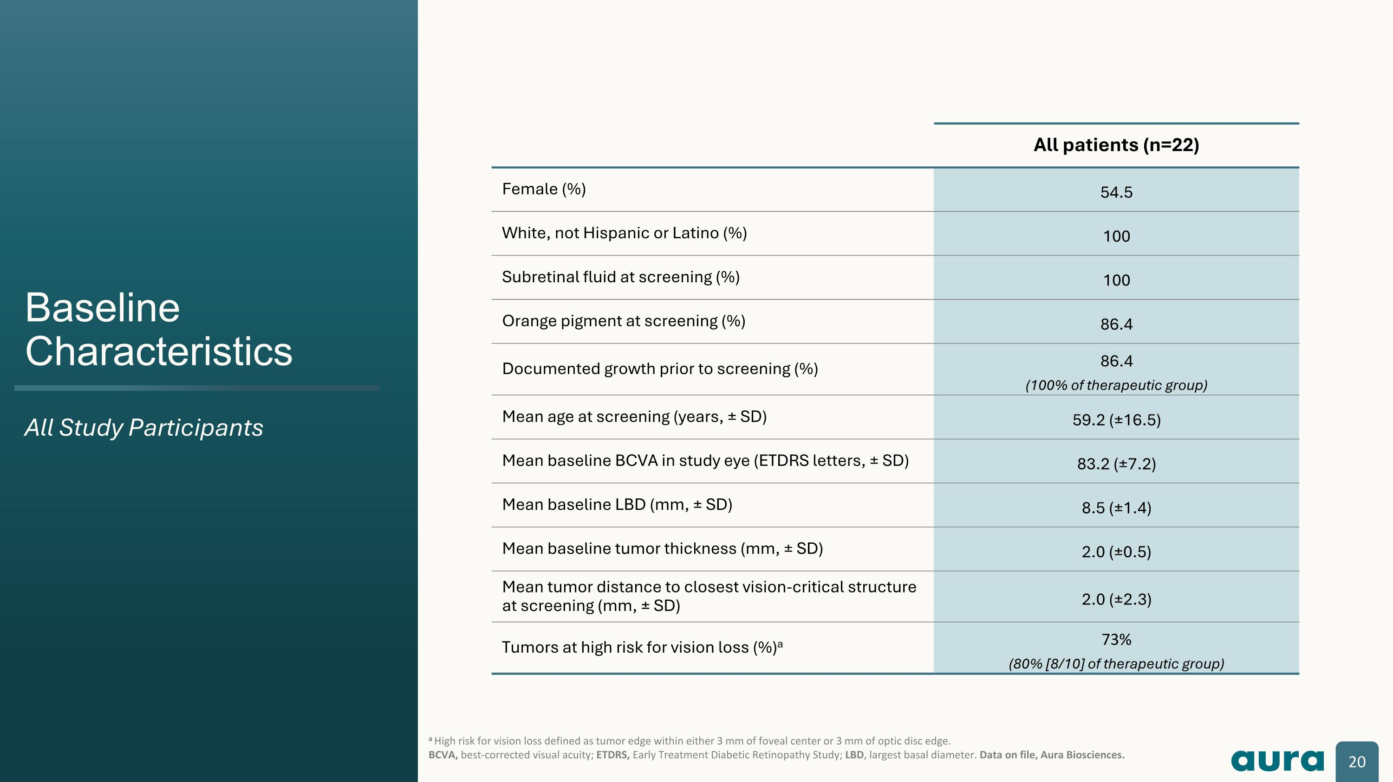
Baseline Characteristics All Study Participants a High risk for vision loss defined as tumor edge within either 3 mm of foveal center or 3 mm of optic disc edge. BCVA, best-corrected visual acuity; ETDRS, Early Treatment Diabetic Retinopathy Study; LBD, largest basal diameter. Data on file, Aura Biosciences. All patients (n=22) Female (%) 54.5 White, not Hispanic or Latino (%) 100 Subretinal fluid at screening (%) 100 Orange pigment at screening (%) 86.4 Documented growth prior to screening (%) 86.4?(100% of therapeutic group) Mean age at screening (years, ± SD) 59.2 (±16.5) Mean baseline BCVA in study eye (ETDRS letters, ± SD) 83.2 (±7.2) Mean baseline LBD (mm, ± SD) 8.5 (±1.4) Mean baseline tumor thickness (mm, ± SD) 2.0 (±0.5) Mean tumor distance to closest vision-critical structure at screening (mm, ± SD) 2.0 (±2.3) Tumors at high risk for vision loss (%)a 73%?(80% [8/10] of therapeutic group)

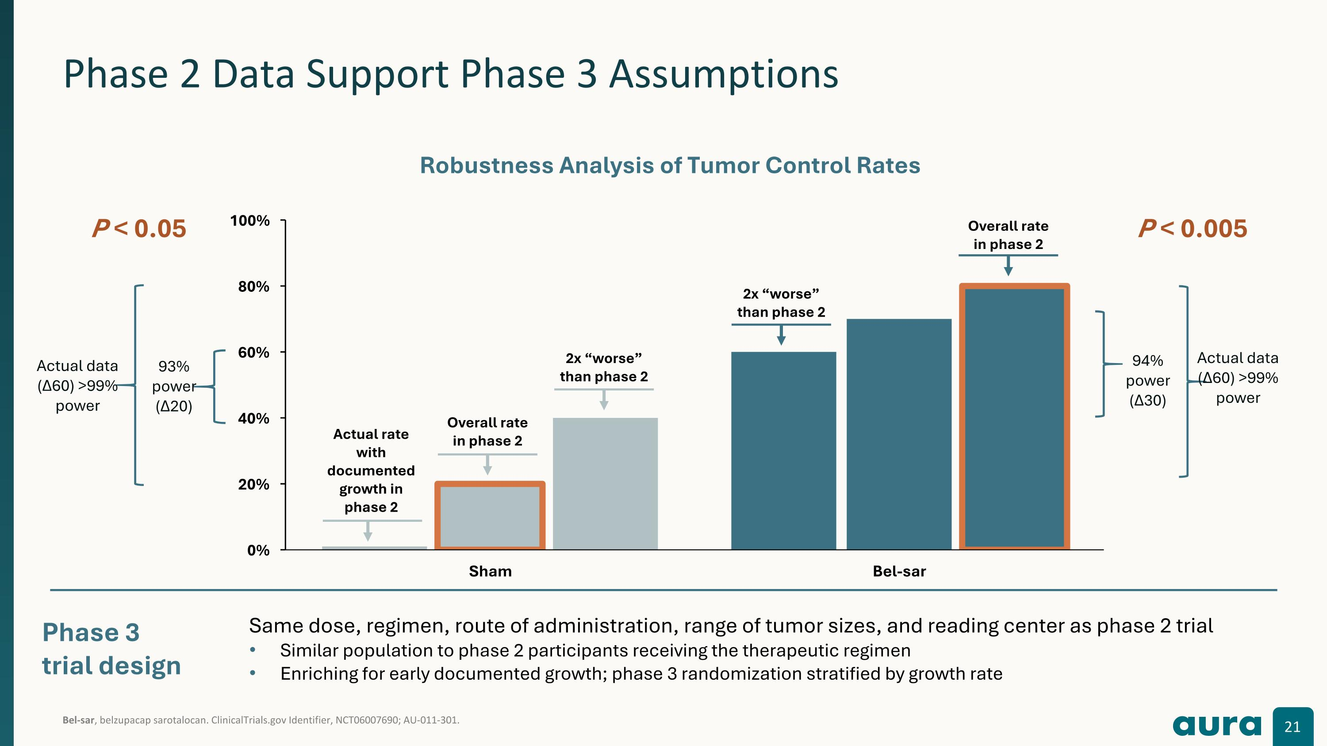
Bel-sar, belzupacap sarotalocan. ClinicalTrials.gov Identifier, NCT06007690; AU-011-301. Phase 2 Data Support Phase 3 Assumptions Phase 3 trial design P < 0.005 93% power (Δ20) Actual data (Δ60) >99% power P < 0.05 Robustness Analysis of Tumor Control Rates Overall rate?in phase 2 2x “worse” than phase 2 2x “worse” than phase 2 Actual rate?with documented growth in?phase 2 Overall rate?in phase 2 94% power (Δ30) Actual data (Δ60) >99% power Same dose, regimen, route of administration, range of tumor sizes, and reading center as phase 2 trial Similar population to phase 2 participants receiving the therapeutic regimen Enriching for early documented growth; phase 3 randomization stratified by growth rate

